Chapter 5

Traversing chemical space with active learning for low-data drug discovery

5.1 Abstract

Deep learning is accelerating drug discovery. However, current approaches are often affected by limitations in the available data, either in terms of size or molecular diversity. Active deep learning has high potential for low-data drug discovery, as it allows iterative model improvement during the screening process. However, there are several “known unknowns” that limit the wider adoption of active deep learning in drug discovery: (a) what the best computational strategies are for chemical space exploration, (b) how active learning holds up to traditional, non-iterative, approaches, and (c) how it should be used in the low-data scenarios typical of drug discovery. To provide answers, this study simulates a low-data drug discovery scenario, and systematically analyses six active learning strategies combined with two deep learning architectures, on three large-scale molecular libraries. We identify the most important determinants of success in low-data regimes and show that active learning can achieve up to a six-fold improvement in hit discovery compared to traditional screening methods.

The work in this chapter has been published as: D. van Tilborg and F. Grisoni, …

5.2 Introduction

One of the key applications for deep learning¹ for drug discovery^{2,3} is virtual screening⁴, whereby large commercial libraries (usually consisting of 10³-10⁹ molecular candidates) are prioritized for prospective wet-lab experiments^{4–7}. A major bottleneck of deep learning, however, is the need for sufficient training data⁸, as has been shown in chapter 3. Available ligand-target interaction data are often limited in size and structural diversity, which hampers the use of deep learning models in practice^{9–11}. Furthermore, the chemical composition of commercial screening libraries is often structurally distinct from the training data¹², resulting in potentially unreliable predictions.

Designing nanoparticles with extreme data constraints in chapter 4 supported active learning^{13–15} as a feasible solution to escape training data size (and diversity) bottlenecks. Just like the active learning approach in chapter 4, active learning can also be cast into an iterative screening approach in small molecule drug discovery (Fig 5.1), where instead of performing a single virtual screening experiment, one can test (fewer) molecules across multiple cycles^{13–20}. At each iteration, a selection of molecules is acquired based on model predictions and experimentally tested (for instance, for its biological activity on the intended target). The newly obtained experimental data, together with data previously collected, are then used to update the model, aiming to inform the next iteration. By improving a model over subsequent iterations, active learning bears promise to identify more bioactive molecules using less resources than standard ‘one-shot’ virtual screening approaches¹³.

Although active learning is not a new concept in the molecular domain^{13,14,17–36} (Supplementary Table 1), numerous technical and practical aspects that must be considered when applying active deep learning prospectively remain unaddressed. On one hand, deep learning can offer several advantages over traditional machine learning approaches³⁷, such as transfer learning or flexibility in the molecular representation used. On the other hand, the behavior of active deep learning in data-scarce settings – both in terms of size and molecular diversity – has not been extensively investigated. Even though active (deep) learning is expected to gain relevance in the future in the context of automated molecule discovery and self-driving labs^{38,39}, the current lack of computational guidelines on how to use it in practice might hamper its adoption.

This systematic study aims to illuminate the known unknowns of active deep learning in low-data scenarios using existing high-throughput screening data.

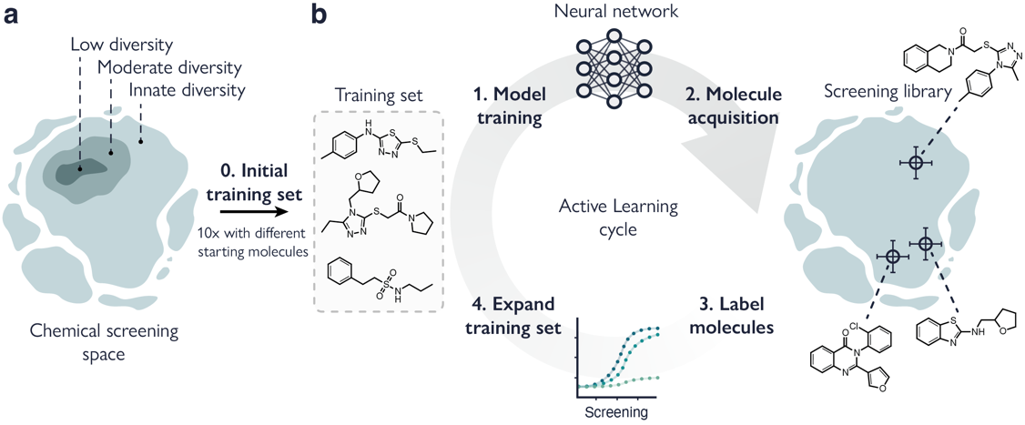
Figure 5.1 | Overview of the experimental setup for low-data active learning. a. A starting set of molecules (64) is selected from the screening library (step 0). This starting set can be sampled from the full library (innate structural diversity) or can be sampled from hierarchical subclusters of molecules with moderate or low structural diversity. b. The active deep learning cycle. From the training set, a model is trained and used to predict bioactivity on all unlabelled molecules in the screening library (step 1). Using an acquisition function, molecules are selected for follow-up (step 2), and subsequent labelling (step 3). Finally, the labelled molecules are added to the training set for the next cycle (step 4).

While deep learning can also be combined with simulations (for instance, molecular dynamics and docking^{14,19,20,35,36}), in this work, we specifically focus on wet-lab data, to emulate a ‘real-world’ hit discovery scenario as much as possible. We focus on several facets of the active learning pipeline to provide mechanistic insights into the hit discovery capability of active deep learning, across different deep learning architectures, molecule acquisition strategies, and macromolecular targets. In particular, we consider the effect of size and structural diversity of the starting molecules, and the benefits of active learning compared to non-iterative approaches, in low- and very-low data regimes. Not only does the proposed framework corroborate the potential of active deep learning, but it also includes recommendations and observations for its prospective application in low-data drug discovery, to ultimately accelerate its adoption.

5.3 Study design

Active learning setup
In this study, we mimicked a low-data drug discovery scenario for hit identification. All experiments followed the same setup (Fig 5.1), whereby active learning models were used to iteratively query a screening library of 100,000 molecules with a maximum screening budget of 1,000 molecules. Each series of active learning experiments started with a small set of 64 molecules (step 0) sampled from the screening library, containing at least one bioactive molecule (see Materials and Methods, Active learning). Notably, this procedure led to 80% of the starting sets containing less than three hits, which reflects a realistic drug discovery scenario, for example, where novel bioactive molecules possessing diverse scaffolds or improved proprieties are sought.^{40,41}

The active learning procedure consisted of four iterative steps:
- Training. A machine learning model was trained on all available labeled data and is then used to perform bioactivity predictions on all unlabeled molecules in the screening library.
- Acquisition. From these predictions, 64 molecules were selected for follow-up using one out of six pre-determined acquisition functions.
- Testing. The acquired molecules were labeled with their corresponding experimental bioactivity (known in advance but not used for model training), to simulate a wet lab testing procedure.
- Update. All labeled molecules were added to the training set, for the next cycle (step 1).

This four-step cycle was repeated until 1,000 molecules were screened. The acquisition size (step 2) was determined through preliminary experiments where we compared acquiring 16, 32, or 64 molecules per cycle and found no significant differences in performance (see Supplementary Fig. 5.1). Using this setup, we investigated the impact of the following factors on the effectiveness of active learning: (a) the structural diversity of the starting set (comparing three levels of diversity), (b) the chosen deep learning approach (two approaches), and (c) the acquisition function used to decide what molecules to select (six acquisition functions). These systematic analyses were each carried out on three macromolecular targets in replicates of ten with different random starting sets, to ensure the robustness and generalizability of the obtained conclusions. These factors are explained below.

Table 5.1: Summary of the data. Subsets of three datasets from LIT-PCBA⁴² were used: Pyruvate kinase M2 (PKM2, agonism), Aldehyde dehydrogenase 1 (ALDH1, inhibition), and Vitamin D receptor (VDR, antagonism). Mean and standard deviations of the number of hit molecules in the 10 starting sets are reported. An external test set of 20,000 molecules served to monitor performance over cycles.
Dataset | Screening library size | Test set size | No. hits in starting set (average)
PKM2 | 100,000 (223 hits, 0.2%) | 20,000 (44 hits, 0.2%) | 1.2 ± 0.4
ALDH1 | 100,000 (4,986 hits, 5.0%) | 20,000 (997 hits, 5.0%) | 4.1 ± 3.1
VDR | 100,000 (239 hits, 0.2%) | 20,000 (48 hits, 0.2%) | 1.2 ± 0.4

Chosen macromolecular targets
To mimic real drug-screening experiments that rely on large screening libraries, we used three high-throughput screening datasets from LIT-PCBA⁴², each for a different biological target. Not only are LIT-PCBA datasets designed to mimic the hit/potency distribution of typical experimental drug screens⁴², but many of them are also large enough to be used as a ‘screening library’ to simulate prospective active learning campaigns. Here, we selected the three LIT-PCBA datasets containing the most experimentally-validated molecules, which refer to targets of clinical and therapeutic interest^{43–46}.

Data from three macromolecular targets was used:
- Pyruvate kinase M2 (PKM2, agonism).
- Aldehyde dehydrogenase 1 (ALDH1, inhibition).
- Vitamin D receptor (VDR, antagonism).

For each dataset, 100,000 molecules were randomly extracted, preserving the proportion between active and inactive molecules. These molecules served to construct a screening library, from which the starting training set and the successive molecule picks are drawn (Table 1 and Supplementary Fig. 5.2). Analyzing the structural similarity of active and inactive molecules indicates that active chemotypes are not overrepresented in the data (Supplementary Fig. 5.3), further underscoring the suitability of these datasets to simulate a prospective hit finding campaign. An additional set of 20,000 molecules was randomly selected to serve as an external test set for performance monitoring (Table 1).

Levels of structural diversity
To examine the effect of structural heterogeneity in the starting set, we used clustering to artificially create subsets of molecules with different degrees of structural diversity, each of which served as a starting set. Diversity was defined through molecular similarity by computing the Tanimoto coefficient on Extended Connectivity Fingerprints⁴⁷ (ECFPs), which captures the presence of shared substructures among pairs of molecules. Using hierarchical clustering, we selected ten clusters in each dataset with moderate structural diversity (average Tanimoto similarity ranging from 0.26 ± 0.03 to 0.28 ± 0.03, Table 2). Within each of these clusters, another subcluster of molecules with low diversity was identified (average similarity higher than 0.36 ± 0.01, Table 2). This gave us a hierarchy of three levels of structural diversity (Fig 5.1a).

Three hierarchal levels of structural diversity were used:
- ‘Innate’ diversity (the inherent diversity of the full screening library).
- Moderate diversity.
- Low diversity.

When constructing the starting set, molecules could be sampled from areas of each level accordingly. Since our approach is hierarchical, this allowed us to vary molecular diversity in the starting set while staying in the same population of molecules for each of the ten experimental replicates.

Table 5.2: Hierarchy of molecular diversity in starting sets. Molecular diversity is reported as the mean Tanimoto similarity on Extended Connectivity Fingerprints between all molecules in the starting set. For three datasets, the mean similarity of all ten starting sets (n=64) is reported with standard deviations. The higher the mean similarity, the lower the diversity. These values were the best achievable for ten hierarchical subsets large enough to sample the starting set from. PKM2 = Pyruvate kinase M2, agonism; ALDH1 = Aldehyde dehydrogenase 1, inhibition; VDR = Vitamin D receptor, antagonism.
Diversity ↓ | PKM2 | Similarity ↑ ALDH1 | VDR
Innate | 0.14 ± 0.00 | 0.13 ± 0.00 | 0.14 ± 0.00
Moderate | 0.27 ± 0.03 | 0.28 ± 0.04 | 0.26 ± 0.03
Low | 0.46 ± 0.03 | 0.46 ± 0.02 | 0.36 ± 0.01

Deep learning models

Two deep learning strategies were used to predict bioactivity:
- Neural networks (multi-layer perceptron) that learn from ECFPs.
- Graph neural networks, which learn directly from molecular graphs^{5,50}.

Both approaches share the same multi-layer perceptron, which either learns directly from molecular fingerprints, or from the output of several layers of graph convolutions⁴⁸. This enables a direct comparison between ECFPs and molecular graphs. Additionally, these methods enable robust uncertainty estimation through approximate Bayesian modelling. Both methods were implemented as such via anchored ensembling⁴⁹, which produces predictive posterior distributions that closely approximate exact Bayesian methods (see Materials and Methods, Uncertainty estimation). Finally, an ensemble of random forest models was trained using ECFPs to serve as a baseline across experiments (see Materials and Methods, Random Forest control).

Acquisition functions
An important contributor to hit discovery is the so-called acquisition function. The acquisition function determines which molecules are selected for screening and how the training set is expanded, governing hit retrieval and influencing future iterations. Six acquisition functions were investigated as a strategy to select molecules for the next cycle, and for their effect on the active learning performance.
Six acquisition functions were used to select molecules:
- Molecular similarity. Molecules in the screening library with the highest structural similarity (Tanimoto coefficient on ECFPs) to any previously found hit are selected.
- Exploitation. Molecules with the best model predictions are selected (Eq. 6).
- Exploration. Molecules with the most uncertain predictions are selected (Eq. 7), with the goal of ‘patching knowledge gaps’ in the model.
- Mutual Information⁵³. Based on Bayesian Active Learning by Disagreement (BALD)⁵³, molecules with the lowest mutual information (Eq. 8) are selected from the screening library. Mutual information is low when there are many possible ways of predicting the data with high certainty, given the same model.
- Exploitation without retraining. Molecules are selected with exploitation using a model trained on just the start dataset (Eq. 6). This method resembles traditional ‘one-shot’ virtual screening where a single model prioritizes the molecules for the whole screening experiment.
- Random acquisition. Molecules are randomly selected from the screening library. This method serves as a control.

Evaluation of active deep learning
The factors investigated in this study were evaluated for their effect on hit enrichment across active learning cycles. This was quantified using the enrichment factor (EF)⁵⁰, which captures the ratio between the number of hits found among all acquired molecules and the number of hits expected in selecting the same number of molecules at random from the screening library. Enrichment factor values larger than 1 indicate methods that can enrich a selection of hits more than a random pick (the higher, the better), while enrichment factor values lower than 1 perform worse than random at hit retrieval.

5.4 Results

Structural diversity: nature versus nurture
The active learning process is ‘seeded’ by the starting data that are available on a given target of interest (and their structural diversity), with usually little or no control over what molecules are available for training. Here were tested the effect of the structural diversity of the starting set on subsequent active learning cycles. We compared starting sets with different degrees of structural diversity: low, moderate, and the innate diversity of the screening libraries.

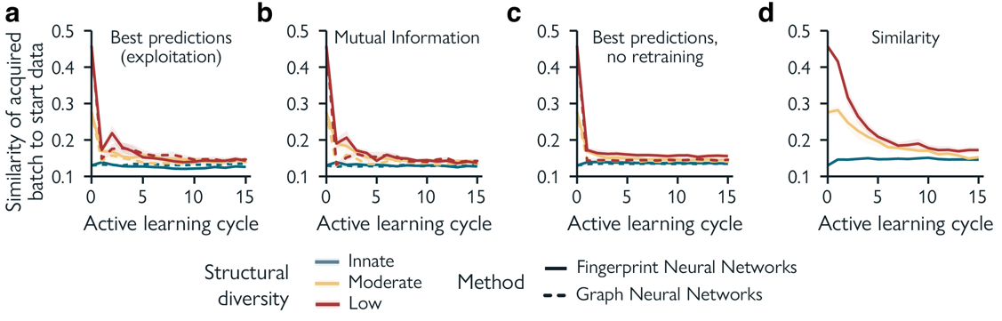
Figure 5.2 | The effect of structural diversity in the starting data. Using the ALDH1 dataset, 64 molecules are acquired each cycle. Data is represented as the mean ± SEM of 10 experiments with different random starting molecules. Structural diversity is defined as mean Tanimoto similarity within the starting set (Table 5.2). a. Molecule acquisition based on best predictions (exploitation). b. Molecule acquisition based on mutual information. c. Molecule acquisition based on best predictions (exploitation) without updating models. d. Similarity-based molecule acquisition. Since molecules are not acquired based on model predictions, but through molecular similarity, results for ECFP- and graph-based neural networks are identical.

We found that, in general, the starting molecular diversity (its ‘nature’) has little influence on the diversity of the molecules acquired later (Fig 5.2) or hit retrieval (Supplementary Fig. 5.4) – owed to active-learning selections (‘nurture’). The initial structural bias is quickly compensated for in the first 1-5 cycles for most methods (corresponding to 64-320 acquired molecules, Fig 5.2) and converges to the levels of innate diversity of the screening library (Table 5.2). Only for similarity-based acquisition, by definition, the structural bias of the starting set lingers. In a few cases (mainly for exploitative and mutual information-based acquisition functions) fewer hits seem to be found when starting with highly similar molecules, although this proved to not be statistically significant in most cases (Supplementary Fig. 5.4). This behavior is observed regardless of the chosen deep learning approach and datasets. These results indicate that the structural diversity of the starting set does not play a big role in hit identification when screening for several cycles, hence showing the usefulness of iterative train-test-update cycles in traversing chemical space effectively.

Choosing an acquisition function
Choosing how to acquire the next iteration of molecules is arguably one of the most crucial factors in active learning, since it will determine hit allocation and what structure-activity information will be fed back into the model for future screening cycles. In general, active deep learning led to a visible increase in the number of discovered hits across screening cycles, for most of the analyzed acquisition functions (Fig 5.3, Supplementary Table 5.2). We found that the molecule acquisition function, and not the machine learning approach resulted to be the main driver of hit enrichment (Fig 5.3). Exploitative acquisition (selection of the best predicted molecules) and acquisition based on mutual information outperform other acquisition functions when combined with neural networks (Fig 5.3). Perturbation experiments⁵¹ ruled out chance correlation (Supplementary Fig. 5.5), confirming that the observed enrichment is related meaningful structure-activity relationships. Explorative acquisition (selection of the most uncertain molecules) yields the poorest hit enrichment across all targets. The random forest control achieved comparable (PKM2 and ALDH1) or better (VDR) enrichment than deep learning (two-sided, paired, Wilcoxon signed-rank tests, α = 0.05). Interestingly, random forest showed opposite performance with explorative or mutual information-based acquisitions. This might be due to the mathematical differences in predicted probabilities between random forests and Bayesian neural networks, which are used to compute entropy-driven acquisition functions (Eq. 3 and 4). These differences suggest that the acquisition function should be evaluated in combination with the chosen machine/deep learning approach. Given the numerous known unknowns about the behavior of neural networks in active learning, the remainder of this paper will primarily focus on deep learning.

Across all datasets and most molecule acquisition functions, fingerprint neural networks outperform graph-based models in hit enrichment. Graph neural networks, however, achieve a slightly higher prediction accuracy on the PKM2 and ALDH1 datasets (Supplementary Table 5.3 and Supplementary Fig. 5.6). Although graph-based methods tend to find less hits, they exhibit similar behavior to the fingerprint-based methods in the (relative) performance of acquisition functions across iterations.

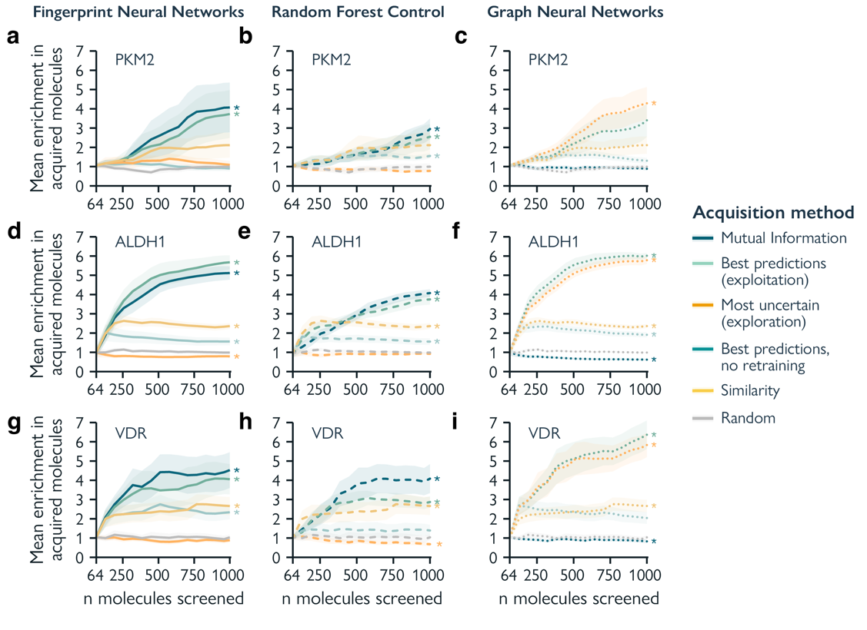
Figure 5.3 | Effect of acquisition functions on hit discovery. Enrichment factor of all acquired molecules with models trained using ECFPs and molecular graphs, reported across three different datasets. Data is represented as the mean ± SEM of 10 experiments with different random starting molecules. Molecular fingerprint (ECFPs) neural networks are reported in the left-hand column (solid line), graph neural networks in the middle column (dashed line), and the random forest control based on ECFPs in the right column (dotted). Every row represents one dataset: PKM2 (a, b, c). ALDH1 (d, e, f); VDR (g, h, i). Two-sided, paired, Wilcoxon rank-sum tests were performed without multiple testing correction on the last cycle between random acquisition (grey) and the other acquisition methods, with * denoting significant differences (p < 0.05). Statistical tests comparing the machine/deep learning methods can be found in Supplementary Table 5.2.

Regardless of the machine learning approach used, active learning achieves a notable increase in the number of hits compared to screening the same number of molecules in just one go (‘one-shot’). For instance, active learning with exploitation can lead to a two- to four-fold enrichment compared the corresponding ‘one-shot’ approach. Interestingly, iterative similarity-based acquisition (not requiring any machine learning in principle) also yields higher enrichment than ‘one-shot’ virtual screening across the board, although lower than active deep learning. Especially in early iterations, similarity-based acquisition seems to be highly effective, even when compared to the best performing active learning methods. This suggests that the choice of the acquisition function (for instance, deep learning-based vs similarity-based) also needs to consider the total ‘budget’ of molecules to be tested experimentally.

Chemical space exploration
Finding structurally novel hits is often one of the objectives of virtual screening since it might increase the chances of success of hit-to-lead optimization and provide access to unexplored regions in the chemical space. Hence, we analyzed the hits acquired (in terms of physicochemical and structural features) at the end of the iterative procedure, compared to the respective starting set. As a case study, we dive into the ALDH1 dataset and fingerprint-based neural networks. Based on qualitative projections of chemical space, active deep learning resulted to be able to explore broader regions of the chemical space (Fig 5.4a), whereas a traditional ‘one-shot’ (Fig 5.4b) or similarity-based (Fig 5.4c) approaches stayed in ‘narrower’ regions.

To get more nuanced insights into the impact of the acquisition functions in the capacity to traverse the chemical space, we analyzed the physicochemical properties of the acquired hits over iterations. Different acquisition functions steer a screening experiment towards populations of molecules with different physicochemical properties than the starting set. An example experiment is analyzed for exploitative and mutual information-based acquisitions, which show similar hit enrichment. Despite their similar performance (Fig 5.3), when starting from the same set of molecules, the physicochemical properties of the hits these functions acquire (for example, total polar surface area and molecular weight) might progressively diverge over screening cycles (Fig 5.4d, e). This indicates that different acquisition functions can discover distinct chemistry.

Furthermore, we curated a list of 50 chemically relevant molecular substructures (Supplementary Table 5.4), to monitor chemical space exploration across active learning cycles (see Supplementary Fig. 5.7 for other datasets and machine/deep learning methods). We found that random acquisition and exploration (selection of most uncertain molecules) are the best acquisition methods in terms of (global) early enrichment of new substructures, in line with previous work¹³ (Fig 5.4f, Supplementary Fig. 5.7).

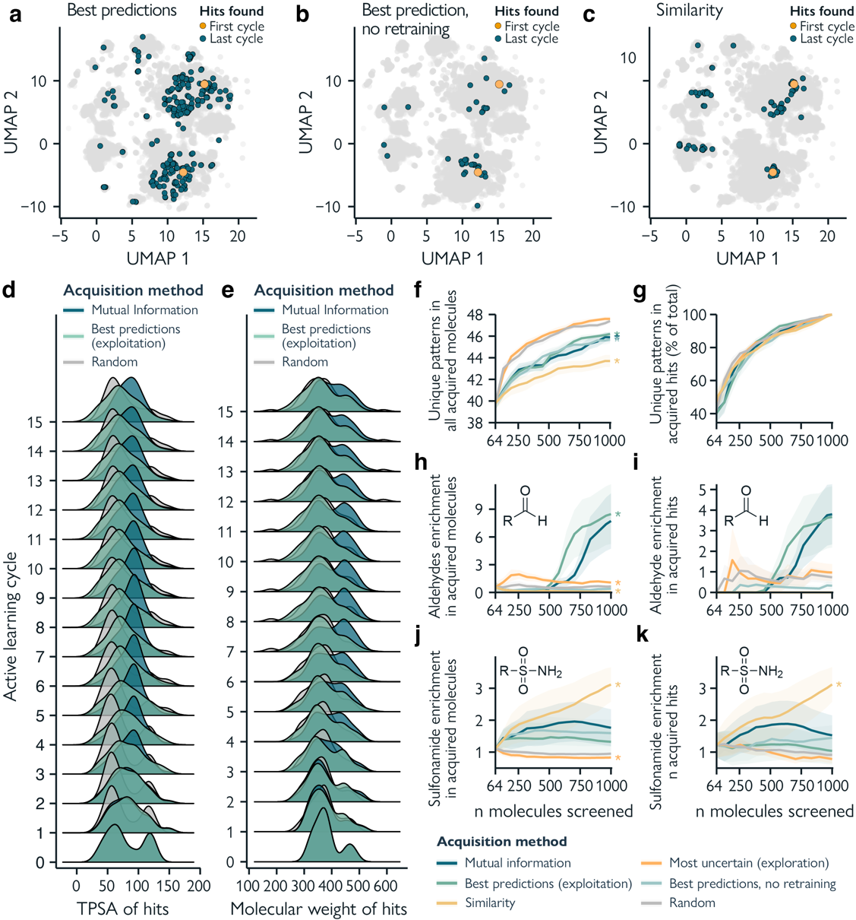
Figure 5.4 | The acquisition function determines the voyage through chemical space. Using the ALDH1 dataset, 64 molecules were acquired each cycle with models trained on ECFPs. a-c. Example case of all hit molecules found in the first (orange) and last (dark blue) active learning cycle using three acquisition methods. Here, all molecules in the screening library (n=100,000, depicted in light grey) are visualized in two dimensions using UMAP⁵² on RDKit⁵³ molecular descriptors (see Materials and Methods, Chemical space visualization). Every point represents a molecule in the dataset, with the starting and final hits highlighted. The closer the molecules in the projection, the more similar their physicochemical properties. d, e. Distribution of molecular properties (total polar surface area [TPSA] and molecular weight) of acquired hit molecules throughout cycles for two high-enrichment acquisition functions (mutual information and best predictions) in comparison with random acquisition, for a selected experimental replicate. f. The number of unique chemically relevant molecular substructures found across all acquired molecules. g. Unique molecular substructures found in hit molecules per acquisition method, normalized by the number of hits found. h. The enrichment of aldehydes in acquired molecules. i. Enrichment of aldehydes among found hits. j. The enrichment of sulphonamides in acquired molecules. k. Enrichment of sulphonamides among found hits. Two-sided, paired, Wilcoxon rank-sum tests were performed without multiple testing correction on the last cycle between random acquisition (grey) and the other acquisition methods for f-k, with * denoting significant differences (p < 0.05). Data in f-k is represented as the mean ± SEM of 10 experiments with different random starting molecules.

Similarity-based acquisition, by definition, is the slowest at finding novel chemistry across cycles. When looking at hit molecules only, exploitation and mutual information-based acquisition yield the highest number of new (unique) substructures. Hence, in general, mutual information is the acquisition method that overall discovers more hits and provides a high degree of novel substructure exploration (both overall and in the retrieved hits). However, when normalizing these statistics by the number of hits found by each method (Fig 5.4g), no single method finds novel substructures faster. Moreover, the random forest control with explorative acquisition does not yield a higher number of newly explored chemical substructures, despite the higher enrichment (Supplementary Fig. 5.7c, f, i). No statistically significant difference was observed in the number of novel substructures found across deep learning methods when comparing the best performing acquisition methods (Wilcoxon rank-sum test, p < 0.05).

Interestingly, active deep learning showed an ‘adaptive behavior’ in the molecular substructures that are acquired during screening. For example, aldehydes – overrepresented in ALDH1 hits (1.06%) compared to all molecules (0.18%) – were, at some point, prioritized by exploitative and mutual information-based acquisition functions (Fig 5.4h). In turn, the enrichment of aldehydes found among hits increased accordingly (Fig 5.4i). This indicates that relevant structure-activity relationships can be picked up along the way based on newly discovered information. This is not true for methods not based on active learning. In fact, irrelevant substructures might get prioritized purely by their presence in the starting set. For example, in the ALDH1 dataset, similarity-based acquisition started to prioritize sulphonamides (Fig 5.4j, h), which are common in this dataset, but not overrepresented in hit molecules (occurring in 14.32% of hits and 12.71% of non-hits). The adaptive nature of active learning allows it to change course during screening and might prevent models to get stuck in specific areas of the chemical space. This motivates once more the adoption of active learning to explore novel chemistry.

How low can you go?
To stress-test active learning in low-data regimes, we further decreased the number of starting molecules available for training. We used differently sized random starting sets, containing as little as 2 molecules in the most extreme scenario, up to 64 molecules (Extended Data Fig 5.1, Supplementary Fig. 5.8). The best performing acquisition function for deep learning methods (mutual information) was employed with both ECFP-based and graph-based neural networks.

Like in previous experiments (Fig 5.3), ECFP-based neural networks outperform graph-based models in hit enrichment (Extended Data Fig 5.1, Supplementary Fig. 5.8), with the latter struggling particularly in extremely low-data starts (2 to 4 molecules). Larger starting sets tend to be better, with the magnitude of the effects of data size reduction depending on the target. In many cases, though, there are no statistically significant differences between different start set sizes. This suggests that active learning still showed notable hit enrichment when faced with little initial data (for instance, less than 10 molecules). In early screening cycles, similarity search (Extended Data Fig 5.1), which would be a natural choice for virtual screening⁵⁴ in extremely-low data scenarios, performs on par with active learning. Yet, active learning progressively shows a substantial improvement over similarity search throughout subsequent cycles (Extended Data Fig 5.1). This motivates the adoption of active learning instead of similarity search for projects that are more time- and cost-permissive and that would allow a larger number of iterations (for instance, more than five).

Finally, to test the boundaries of active deep learning for hit discovery, we have applied it to six additional datasets from the same source⁴² (FLAP endonuclease, Glucocerebrosidase, Lysine acetyltransferase 2A, Isocitrate dehydrogenase, Kappa opioid receptor, and Beta2 adrenergic receptor). We selected ‘low yield’ datasets, meaning datasets containing a low number of discoverable hit molecules (from 5 to 100 hits out of 100,000 molecules, Supplementary Table 5.5). We used 64 starting molecules, as before. The relative performance across different acquisition functions proved consistent with previous observations (Supplementary Fig. 5.9 and Fig 5.3), showing that our results apply more broadly. However, in the extreme ‘low yield’ cases (5-11 hits), all analyzed methods struggle – possibly owed to the lack of sufficient information on the structure-activity relationship in the data. Finally, we found a statistically significant relationship between the ability to discover hits and the number of available hits in the screening library by analyzing all nine datasets together (Kendall’s τ test, p < 0.05, Supplementary Fig. 5.10) – especially for active learning combined with exploitative or mutual information-based acquisition. On one hand, these results indicate that the success of data-driven methods might be limited in extreme ‘information-poor’ scenarios, but they also suggest that the more there is to learn from a library, the more effective active learning is over traditional screening methods.

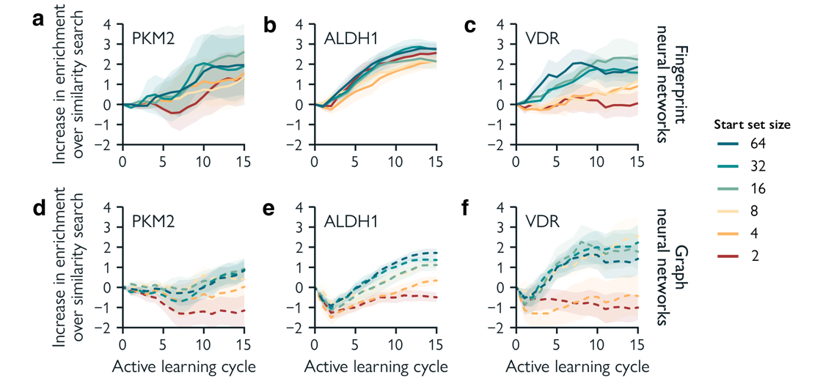Figure 5.5 | The increase in enrichment factor of models acquiring molecules using mutual information over similarity search across active learning cycles for different starting set sizes. Data is represented as the mean ± SEM of 10 experiments with different random starting molecules. Molecular fingerprints (ECFPs) neural networks are reported on the left-hand column, and graph neural networks on the right-hand column. Every row represents one dataset: a, b. PKM2, c, d. ALDH1, e, f. VDR. Two-sided, paired, Wilcoxon rank-sum tests were performed without multiple testing correction on the last cycle between the biggest start set size of 64 (dark blue) and the other start set sizes, with * denoting significant differences (p < 0.05).

Guidelines for prospective active learning
In this systematic study, we presented a reference framework for active deep learning in low-data drug discovery. We examined the behavior of active deep learning models across a range of different hit identification scenarios and expect the insights gathered in this study to assist with strategic experimental design of active learning campaigns in low-data hit discovery settings. For this end, we present five general guidelines based on our findings:

- Active learning can find more bioactive molecules in (extreme) low-data settings (up to a six-fold hit enrichment in our case) compared to traditional screening methods like similarity-search or ‘one-shot’ virtual screening. However, starting out with more data is generally better.
- Active learning is more effective when screening for several cycles, for instance, five or more as per our experimental setup. With a restricted screening budget (in the order of dozens of molecules), a similarity-based approach might prove a better solution.
- The biggest factor driving hit retrieval is the chosen acquisition function, which controls what molecules are selected for follow-up at each cycle. Using best predictions (exploitation) or a mutual information-based acquisition method yielded the most bioactive molecules in our experiments. These acquisition methods present no downside in their ability to discover diverse molecules.
- A low structural diversity of the initial training set does not seem to affect hit discovery in later active learning cycles. We showed that a lack of diversity is rapidly ‘corrected’ for within the next 1-5 screening cycles.
- A fingerprint-based deep learning approach has a better capacity to identify novel hits and is more apt to low-data settings compared to graph neural networks.

5.5 Discussion

Our results corroborate active learning as an effective tool for drug discovery, especially in low-data scenarios, in terms of dataset size, structural bias, and class imbalance. Since the method of acquiring molecules proved to be the main performance driver, there is ample room for improved acquisition functions. Acquisition functions that consider a more chemistry-centered approach, on top of model predictions, bear particular promise to improve molecular novelty among found hits. In this study, we use an approximate Bayesian approach for uncertainty prediction. Different methods of uncertainty quantification might also play a big role in molecule acquisition and could be the object of future research⁵⁵.

While this study is performed retrospectively, our dataset and modelling approaches were chosen to simulate the choices one would have to make in a realistic hit discovery setting. Still, no two drug discovery campaigns are the same, and our proposed guidelines will have to be contextualized for every specific scenario. Also, while the datasets used in this study are based on carefully curated, high-confidence PubChem bioassay data⁴², the extent to which retrospective findings translate to novel macromolecular targets might vary on a case-by-case basis.

Ultimately, the guidelines provided in this study could encourage the adoption of active deep learning in prospective studies. We envision that the adoption of these guidelines will accelerate the shift towards fully automated, deep learning-guided molecule screening, to discover better drugs with fewer resources.

5.6 Materials and Methods

Data pre-processing and analysis
Data pre-processing. The Pyruvate kinase M2 (PKM2), Aldehyde dehydrogenase 1 (ALDH1), Vitamin D receptor (VDR), datasets were downloaded from LIT-PCBA⁴² (accessed on August 2023 at https://drugdesign.unistra.fr/LIT-PCBA). SMILES strings were canonicalized using RDkit⁵³ v. 2022.09.5, after which non-unique SMILES strings and molecules that could not be “kekulized” or featurized (see Molecule featurization) were omitted. All molecules were randomly shuffled. Data was randomly split into a screening library (training set) containing 100,000 molecules and test set, containing 20,000 molecules (Table 5.1). The following supporting datasets were downloaded and processed in the same manner and are described in Supplementary Table 5.4: FLAP endonuclease (FEN1), Glucocerebrosidase (GBA), Lysine acetyltransferase 2A (KAT2A), Isocitrate dehydrogenase (IDH1), Kappa opioid receptor (OPRK1), and Beta2 adrenergic receptor (ADRB2).

Molecule featurization. ECFPs were computed with the following settings: length = 1024 bis, radius = 2. For the featurization of molecular graphs, the following atom features were one-hot-encoded: atom type (C, N, O, S, F, Cl, Br, I, P, Si, B, and Se), implicit atom degree, total atom degree (including hydrogens), explicit valence, implicit valence, total valence, implicit hydrogens, total hydrogens, formal charge, and hybridization. Additionally, atom membership of a set of molecular substructures was binary encoded (Supplementary Table 5.4). ECFPs and all atom features were computed from canonicalized SMILES strings using RDkit⁵³ v. 2022.09.5.

Clustering. Structurally diverse groups of molecules in the training set were identified using average distance agglomerative clustering, implemented with scikit-learn v. 1.2.1. A distance matrix of all molecules was used based on the ‘Tanimoto distance’ (computed as 1 – Tanimoto similarity) on ECFPs. The hierarchical clustering dendrogram was cut at a Tanimoto distance (T_{d}) of T_{d} = 0.8 to find moderately diverse subclusters and at T_{d} = 0.61, T_{d} = 0.70, and T_{d} = 0.70 for PKM2, VDR, and ALDH1 respectively to find smaller, low diversity, sub-subclusters. These specific cut-off values were chosen so that each dataset contained 10 clusters. All subclusters had a minimal size of 128 molecules and contained a single sub-subcluster of 64 molecules. Additionally, clusters should contain a minimal number of hits, comparable to the proportion of hits in the full dataset, as determined by:

$n_{hits}> n_{min}E[Y_{screen}]$, (1)
where n_{hits} is the number of hits in the subcluster, n_{min} is the minimum size of the subcluster, and $Y_{screen}$ is the binary class vector of the full screening library.

Molecular substructure assignation. A set of 50 unique SMILES Arbitrary Target Specification (SMARTS) patterns were used to identify substructures (Supplementary Table 5.4) using RDkit⁵³ v. 2022.09.5.

Chemical space visualization. UMAP (Uniform Manifold Approximation and Projection)⁵² was applied to the set of all available molecular descriptors in RDkit⁵³ v. 2022.09.5 (see Supplementary section Molecular Descriptors) using the Python library umap⁵² (v. 0.5.3). Molecular descriptors were scaled using max scaling and default parameters were used, except for n_neighbors=10 and min_dist=0.25.

Active learning
For each active learning experiment, 64 molecules were selected from the screening library. These molecules are then removed from the library. Every set starts with a random hit molecule, after which the remaining molecules are randomly sampled using a uniform distribution. Until the budget of 1,000 molecules was depleted, a model $M$ was trained on the training set, after which bioactivity predictions were made on the screening library. Using one of five acquisition methods (see Acquisition methods), $n$ molecules are labelled and moved to the training set.

Deep learning
Neural network implementation and architectures. All models were implemented using PyTorch⁵⁶ v. 1.12.1 and PyTorch Geometric⁵⁷ v. 2.2.0. Graph Convolutional Networks (GCN) consisted of an atom embedding layer, followed by three layers of graph convolutions⁴⁸ with batch normalization⁵⁸. Global pooling by summing was then used to get molecular embeddings from atom embeddings. Finally, a multi-layer perceptron (MLP) was used with three fully connected layers with batch normalization⁵⁸. The same MLP architecture was used for models trained on ECFPs. All models used a hidden size of 1024 neurons and were optimized for 50 epochs using the Adam algorithm, with a learning rate of 3 x 10⁻⁴ with mixed precision and a minibatch size of 64. During training, minibatches were resampled based on their class with:

$P_{c}=1-\frac{n_{c}}{N},$ (2)

where $P_{c}$ is the sampling probability for a class $c$, $n_{c}$ is the number of samples of class $c$, and $N$ is the total number of samples.

Uncertainty estimation. For uncertainty estimation, anchored ensembling was used⁴⁹. We used an ensemble of $M=10$ models. For each model, $m∈\{1…M\}$, its parameters $θ_{m}$ are regularized with a set of anchored parameters $θ_{anchor, m}$. Each model is initiated with distinct $θ_{anchor}$, controlled by random seeding. The classification loss in our implementation is defined as:

$Loss=-\frac{1}{N}\sum_{i=1}^{N}{\log\left(p_{m}\left(y_{i} | x_{i}\right)\right)+\frac{λ}{N}{\left\|θ_{m}-θ_{anchor, m}\right\|}^{2}, }$ (3)

where $p_{m}(y_{i}|x_{i})$ is the predicted probability of the label $y_{i}$ given input $x_{i}$ by the $m^{th}$ model, and $λ$ is a regularization coefficient (set to $3×{10}^{-4}$). For estimating the expected value $E$ of a molecule $x_{i}$, we take the mean prediction across all models in the ensemble, as follows:

$E(y_{i}|x_{i})=\frac{1}{M}\sum_{m=1}^{M}{p_{m}(y_{i}|x_{i})}$. (4)

Similarly, the prediction uncertainty for a molecule $x_{i}$ is defined as the mean entropy $H$ over the ensemble:

$H\left(y_{i} | x_{i}\right)=-\frac{1}{M}\sum_{m=1}^{M}{p_{m}\left(y_{i} | x_{i}\right)\log\left(p_{m}\left(y_{i} | x_{i}\right)\right)}.$ (5)

Random Forest control
As a control model, random forest models coupled with ECFPs were implemented using sci-kit learn v. 1.2.1. All models used 100 trees, no maximal tree depth, and a minimal of 2 samples per split. During training, molecules were weighted inversely proportional to their class frequency to mitigate class imbalance. For uncertainty estimation, we used an ensemble of $M=10$ models, with each model using different random seeds. The expected value $E$ and entropy $H$ for a molecule $x_{i}$ was determined according to Eq. 4 and 5.

Perturbation experiments
Perturbation experiments were performed in the form of random controls, as previously suggested⁵¹. For ECFPs, the bits were randomly shuffled for each molecule. For molecular graphs, both atom features and adjacency matrices were randomized. All data is perturbed once at the start of an active learning experiment, so that features stay consistent across active learning cycles. For each experiment, three perturbations with different random seeds were performed.

Acquisition functions
Five acquisition functions were used to select follow-up molecules at each iteration. Each acquisition function $(a)$ greedily selects $n$ molecules based on model prediction on the screening library.

- Similarity-based: samples are selected based on their highest Tanimoto similarity (computed with ECFPs; with 1024 bits and a radius of 2) to any previously acquired hit compound).

- Exploitative: the best predicted samples are selected with:

${a_{exploit}= \text{argmax}}_{n}\left(E\left(y | x\right)\right).$ (6)

- Explorative: most uncertain samples are selected with:

$a_{explore}={\text{argmax}}_{n}\left(H\left(y | x\right)\right).$ (7)

- Mutual Information: selects samples with low mutual information ($I$) with:

$a_{I}={\text{argmin}}_{n}(H(y|x)-E_{M}\left[H\left(y | x,θ)\right]\right).$ (8)

Based on Bayesian Active Learning by Disagreement (BALD)⁵⁹, the left term represents the entropy of the model predictions (uncertainty) and the right term represents the expected value of the entropy of the model predictions for each draw of the model parameters (or ‘disagreement’ between the different models in the ensemble)⁶⁰. To have low mutual information, the model must have many ways of explaining the data with high certainty, meaning, low uncertainty and high disagreement.

- Random: samples are selected from a uniform probability distribution.

Statistics & Reproducibility
All experiments were repeated 10 times by executing the same code with different random seeds, resulting in different molecules to be sampled from the pool of starting data using uniform sampling. Statistical testing was performed using two-sided, paired, Wilcoxon rank-sum test without multiple testing corrections. The two-sided Kendall rank correlation coefficient $τ$ is used to test rank-based association. The screen–train–test data was split using random uniform sampling. No statistical method was used to predetermine sample size of the starting data, as this was one of the assessed variables in this study. No data were excluded from the analyses, and the investigators were not blinded to allocation during experiments and outcome assessment. All experiments can be reproduced using the code provided (see Code availability).

Compute
All simulated active learning experiments were performed on a Lenovo ThinkSystem SD650-N v2 server equipped with Intel Xeon Platinum 8360Y CPUs and NVIDIA A100 (40GB) GPUs, using approximately 10,000 hours of compute time.

5.7 Appendix

Preliminary results on the effects of the acquisition size
An important practical consideration is the number of molecules that are acquired and screened every cycle. A lower acquisition size would result in smaller screening steps. Acquiring fewer molecules per cycle results in more frequent model updates, potentially yielding better models, while simultaneously being lower throughput. To get some insights in the effect of the acquisition size, we compared acquiring either 16, 32, or 64 molecules for follow-up in each active learning cycle. We performed this experiment on only the ALDH1 dataset. We found that the enrichment factor remained similar regardless of acquisition size, showing no statistically significant differences (Supp. Fig 5.1a, b). The same is true for model performance, as measured by the ROC AUC on the test set (Supp. Fig 5.1c, d). In other data modalities, it is generally assumed that a lower acquisition size results in better performance, since models are more frequently updated and a smaller batch of samples has a lower likelihood of containing redundant information^{60,61}. However, when considering molecules, our results do not show this for the number of screening cycles performed in this study.

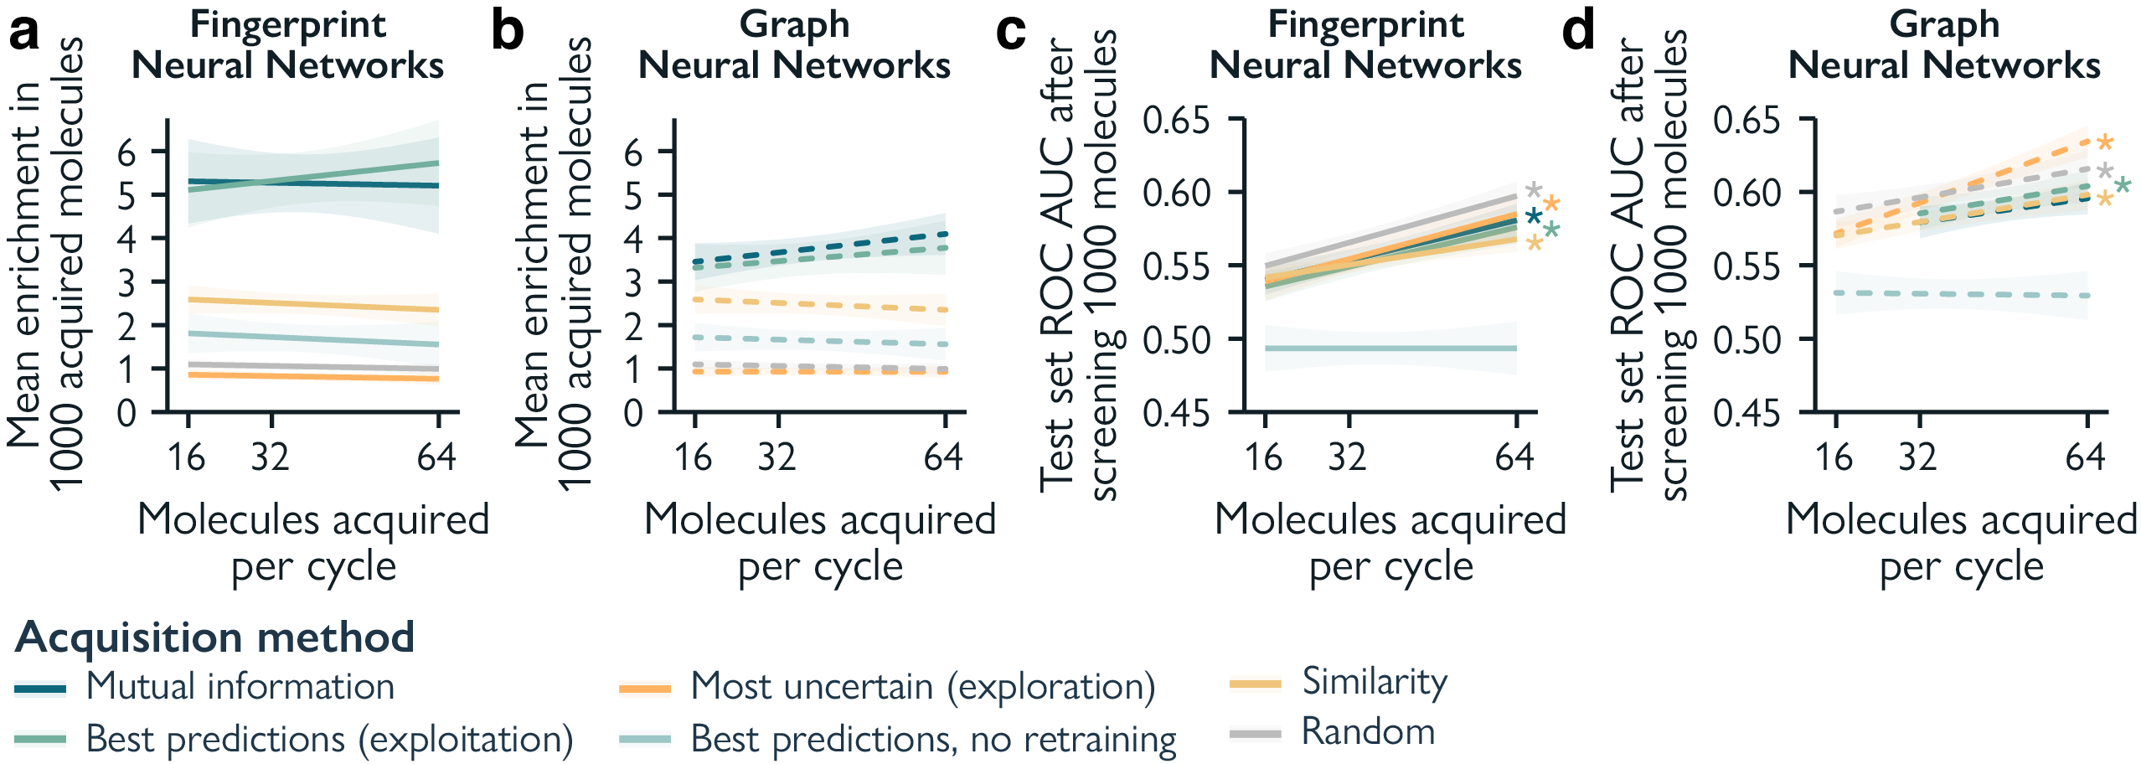
Supplementary Figure 5.1: The effects of the acquisition size on hit enrichment and predictive performance. Data is represented as the mean ± SEM of 10 experiments with different random starting molecules. Predictive performance is reported as the Area under the Receiver Operator Curve (ROC AUC) on the test set. Results are shown for models trained using ECFPs and molecular graphs on the ALDH1 dataset. Kendall’s $τ$ is used to test rank-based association, statistical significance is noted as * = p < 0.05, ** = p < 0.001, *** = p < 0.0001.

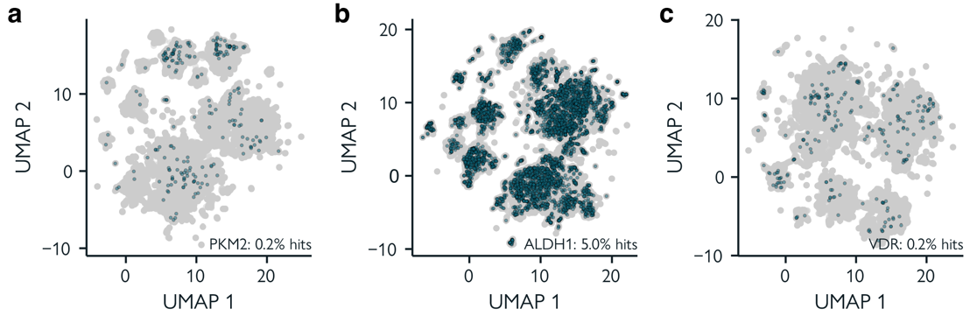
Supplementary Figure 5.2: Visualization of the chemical space of the selected virtual screening libraries. a. Pyruvate kinase M2 data (PKM2), containing 223 hits (agonists) out of 100,000 molecules (0.2%). b. Aldehyde dehydrogenase 1 (ALDH1), containing 4,986 hits (inhibitors) out of 100,000 molecules (5.0%). c. Vitamin D receptor data (VDR), containing 239 hits (agonists) out of 100,000 molecules (0.2%). Here, all molecules in the each dataset (n=100,000) are projected into 2D from a set of molecular descriptors using UMAP⁵² (see Materials and Methods). Every point represents a molecule in the dataset, with hit molecules highlighted in dark blue. The closer the molecules, the more similar their physicochemical properties.

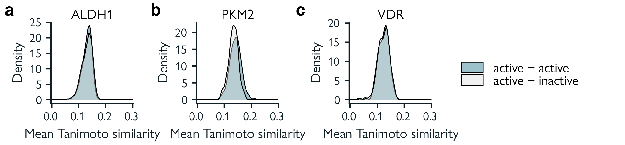
Supplementary Figure 5.3: Hit similarity distribution in the selected virtual screening libraries. a. Pyruvate kinase M2 data (PKM2), containing 223 hits (agonists) out of 100,000 molecules (0.2%). b. Aldehyde dehydrogenase 1 (ALDH1), containing 4,986 hits (inhibitors) out of 100,000 molecules (5.0%). c. Vitamin D receptor data (VDR), containing 239 hits (agonists) out of 100,000 molecules (0.2%). Here, the mean Tanimoto similarity between hits and between hits and inactives is computed. Similarity within actives is not remarkably different from the similarity between active and inactive molecules, indicating that hit chemotypes are not overrepresented.

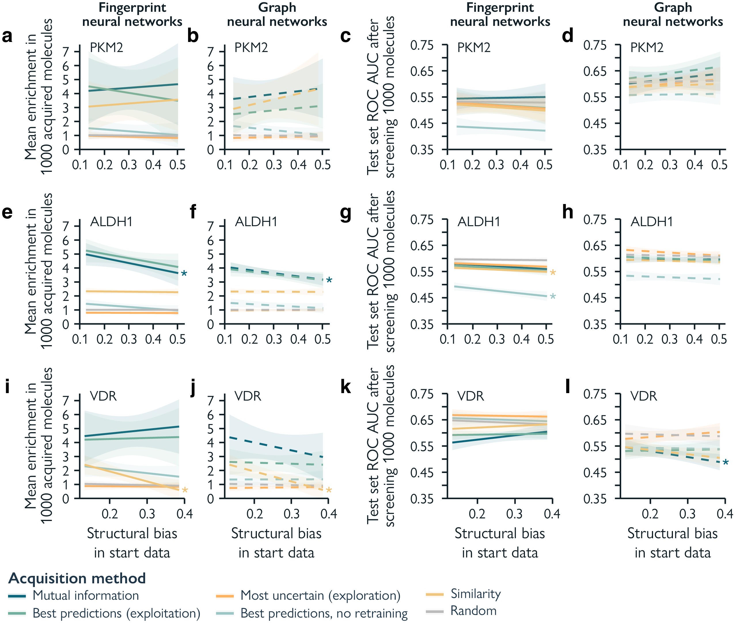
Supplementary Figure 5.4: The effects of structural diversity in the start data on hit enrichment and predictive performance. Predictive performance is reported as the Area under the Receiver Operator Curve (ROC AUC) on the test set. Diversity is reported as the mean Tanimoto similarity of Extended Connectivity Fingerprints⁴⁷ between all molecules in the starting set. The higher the mean similarity, the lower the diversity. Kendalls $τ$ is used to test rank-based association, statistical significance is noted as * = p < 0.05. Data is represented as the mean ± SEM of 10 experiments with different random starting molecules. Molecular fingerprints (ECFPs) are reported as solid lines, and graph neural networks as dashed lines. Every row represents one dataset: a, b, c, d. PKM2, e, f, g, h. ALDH1, i, j, k, l. VDR.

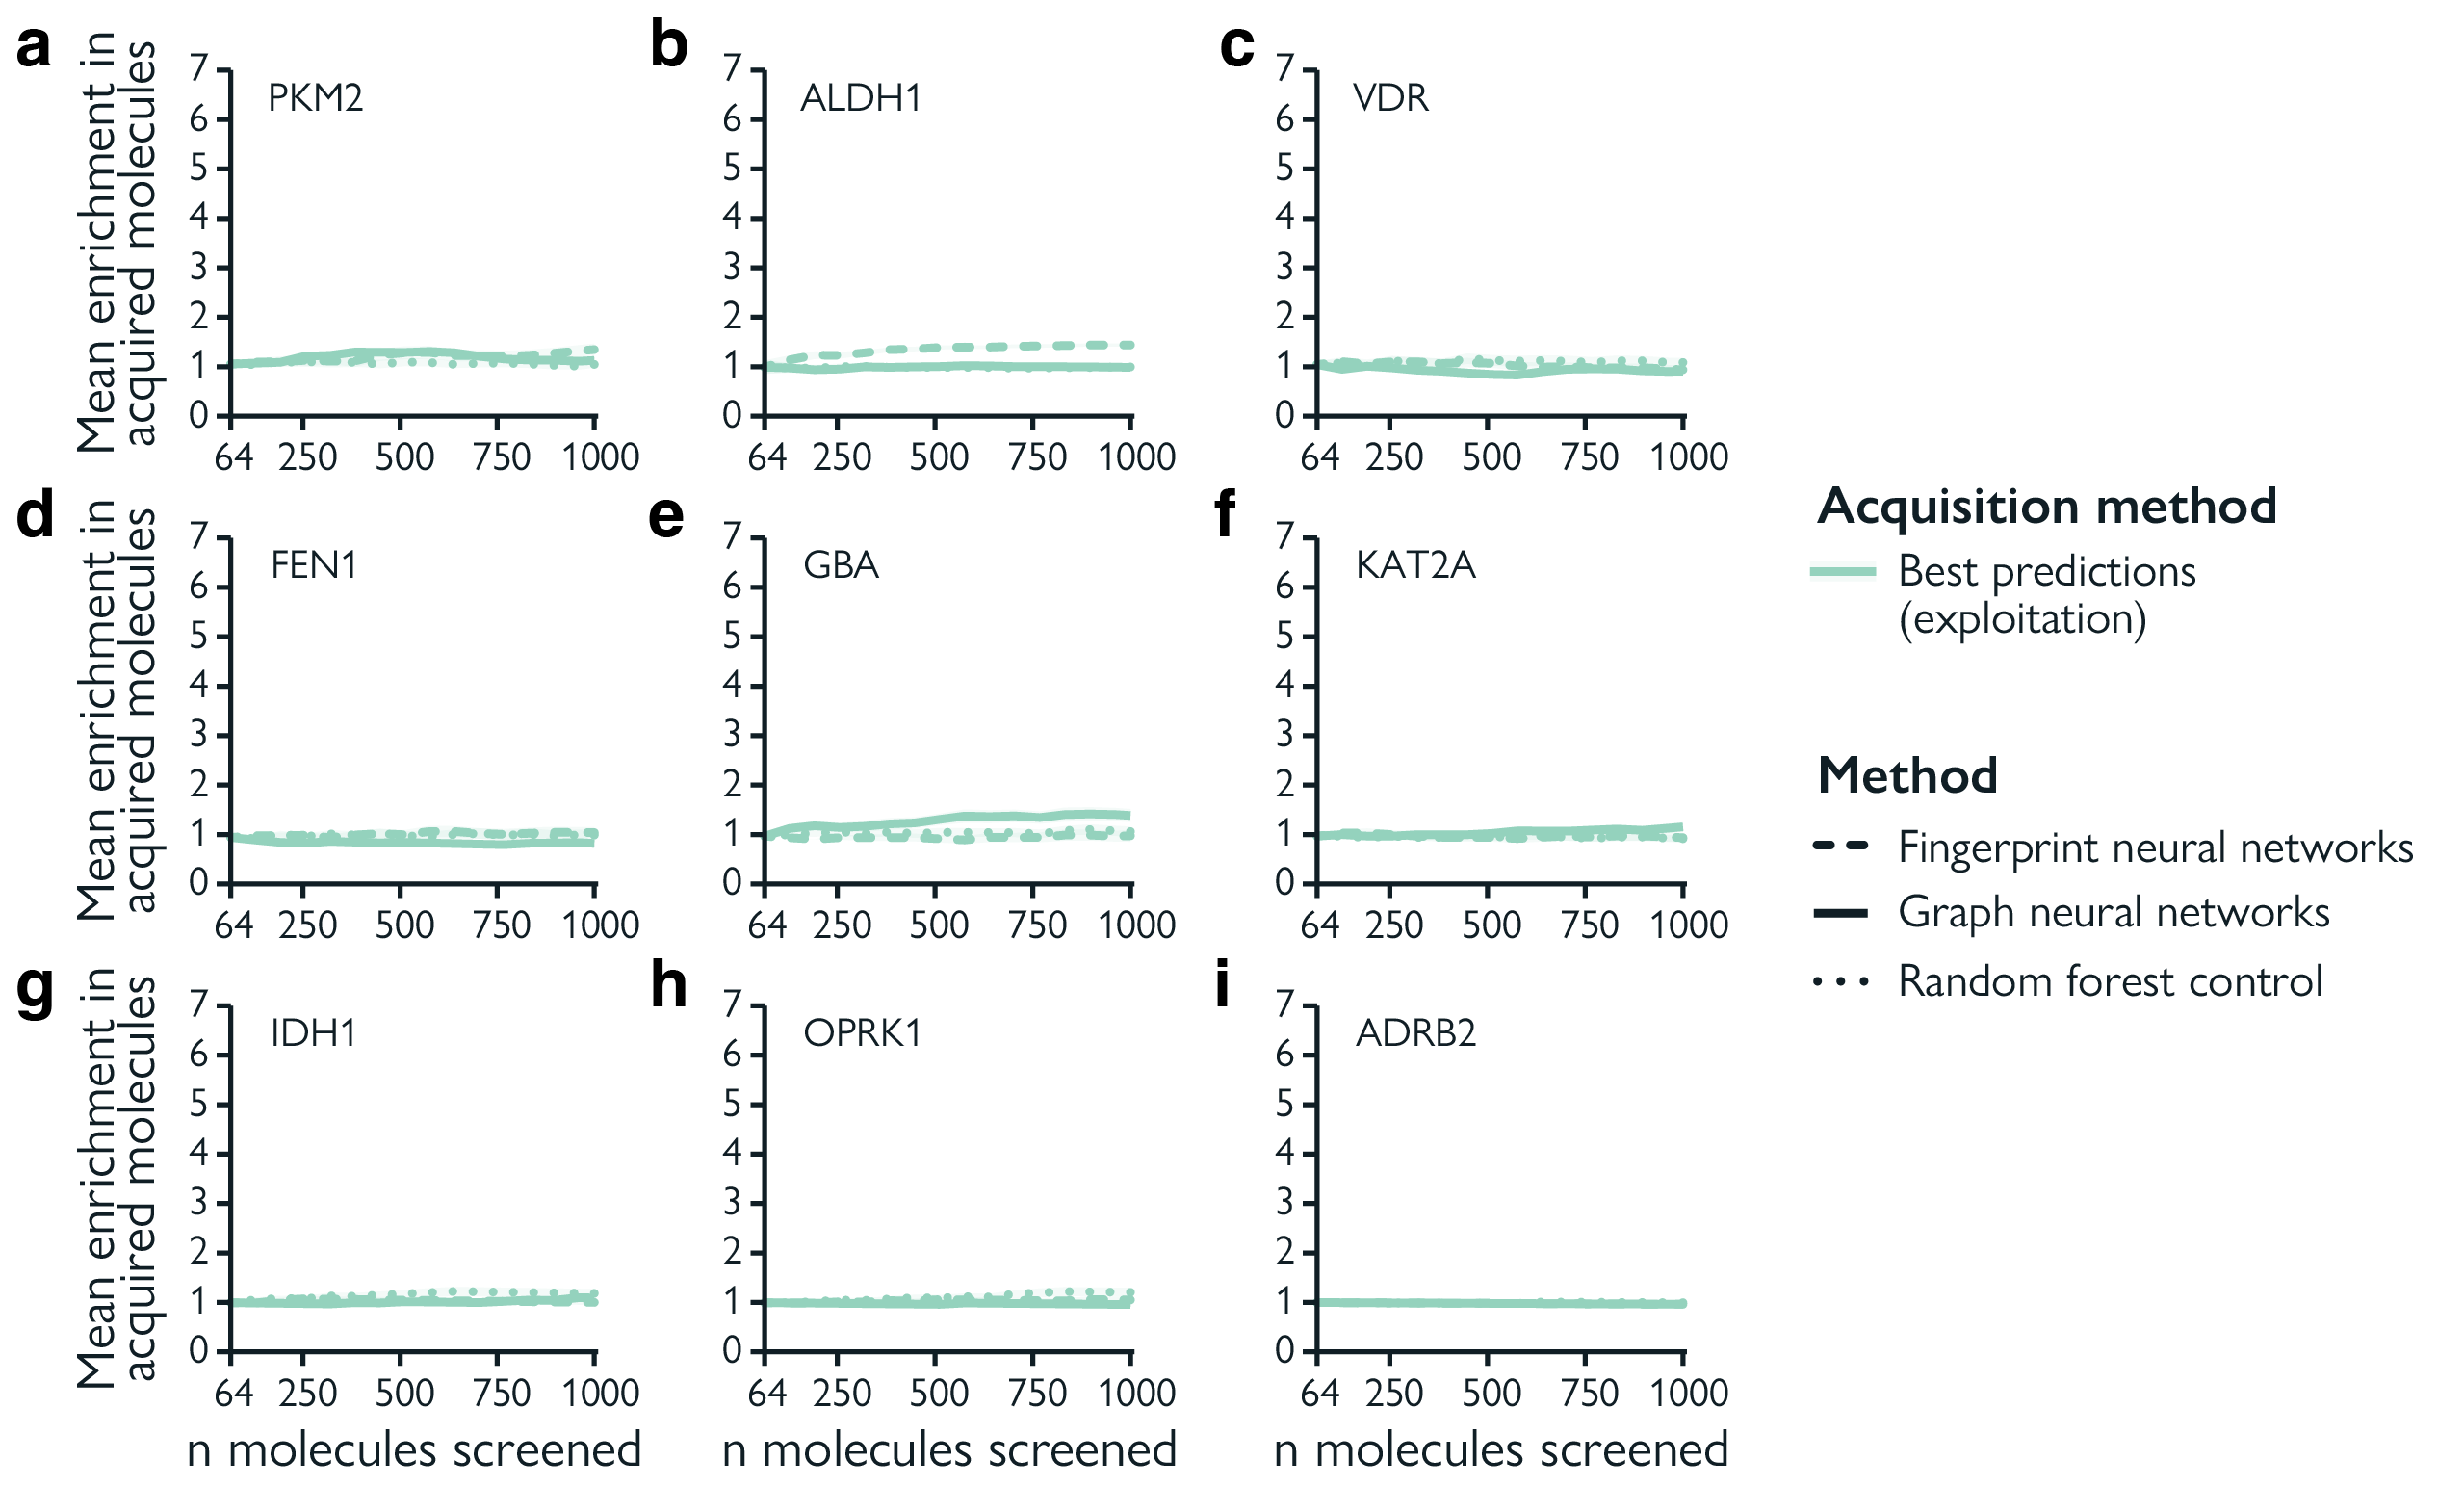
Supplementary Figure 5.5: Hit discovery of active learning with perturbed features. Enrichment factor of all acquired molecules with models trained using randomly perturbed molecular fingerprints (ECFPs) and molecular graphs is reported across nine different datasets. Molecules are acquired using best predictions (exploitation). Data is represented as the mean ± SEM of 10 experiments with different random starting molecules. All data is perturbed once at the start, so features stay consistent across active learning cycles. Additionally, for each experiment, three perturbations with different random seeds are performed. Molecular fingerprint neural networks are reported as solid lines, graph neural networks as dashed lines, and random forest control models using ECFPs as dotted lines. a. Pyruvate kinase M2 (PKM2), b. Aldehyde dehydrogenase 1 (ALDH1), c. Vitamin D receptor (VDR), d. FLAP endonuclease (FEN1), e. Glucocerebrosidase (GBA), f. Lysine acetyltransferase 2A (KAT2A), g. Isocitrate dehydrogenase (IDH1), h. Kappa opioid receptor (OPRK1), i. Beta2 adrenergic receptor (ADRB2).

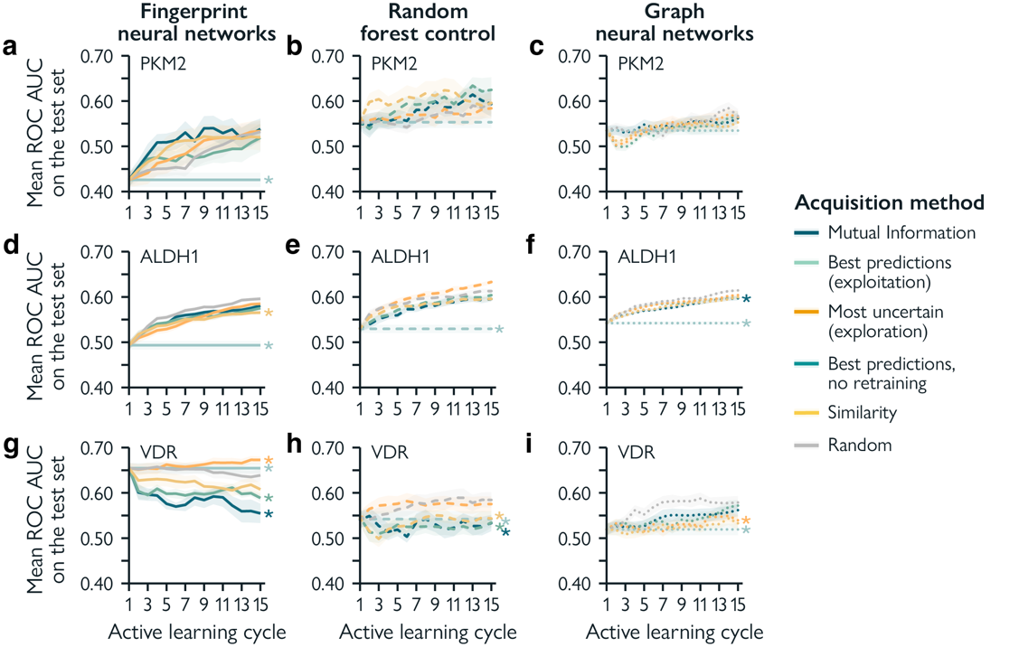
Supplementary Figure 5.6: performance of different active learning strategies. Predictive performance is reported as the Area under the Receiver Operator Curve (ROC AUC) on the test set. The mean ROC AUC over cycles is shown from machine/deep learning models trained using ECFPs and molecular graphs across three different datasets. Data is represented as the mean ± SEM of 10 experiments with different random starting molecules. Molecular fingerprints (ECFPs) are reported on the left-hand column (solid line), graph neural networks on the middle column (dashed line), and a random forest baseline model using ECFPs on the right-hand columns (dotted line). Every row represents one dataset: a, b. PKM2, c, d. ALDH1, e, f. VDR. Two-sided, paired, Wilcoxon Rank Sum tests are performed without multiple testing correction on the last cycle between random acquisition (grey) and the other acquisition methods. Statistical significance (p < 0.05) is denoted as *.
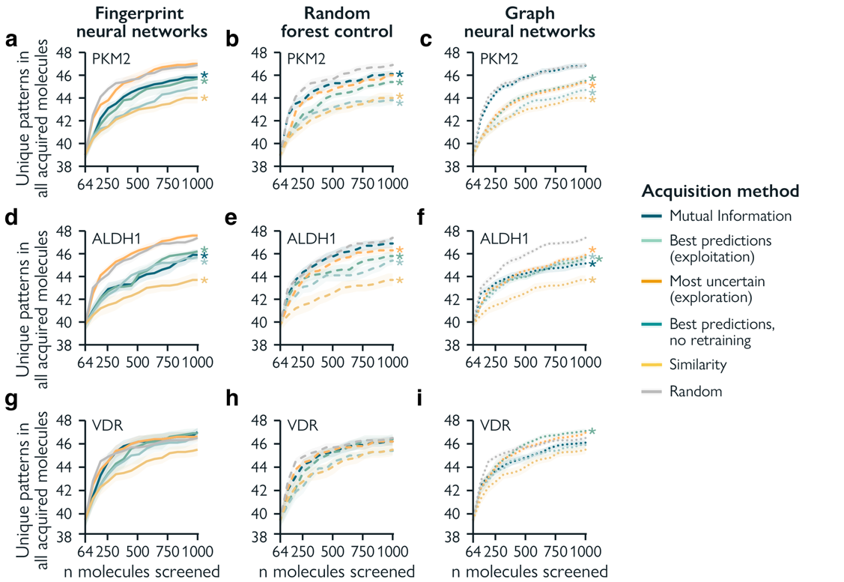
Supplementary Figure 5.7: Substructure discovery in acquired molecules. Molecular fingerprints (ECFPs) in combination with neural networks are reported on the left-hand column (solid line), graph neural networks on the middle column (dashed line), and ECFPs with random forest in the right-hand column (dotted line). Every row represents one dataset: a, b, c. PKM2, d, e, f. ALDH1, g, h, i. VDR. Data is represented as the mean ± SEM of 10 experiments with different random starting molecules, 64 molecules are acquired each cycle. Two-sided, paired, Wilcoxon Rank Sum tests are performed without multiple testing correction on the last cycle between random acquisition (grey) and the other acquisition methods. Statistical significance (p < 0.05) is denoted as *.

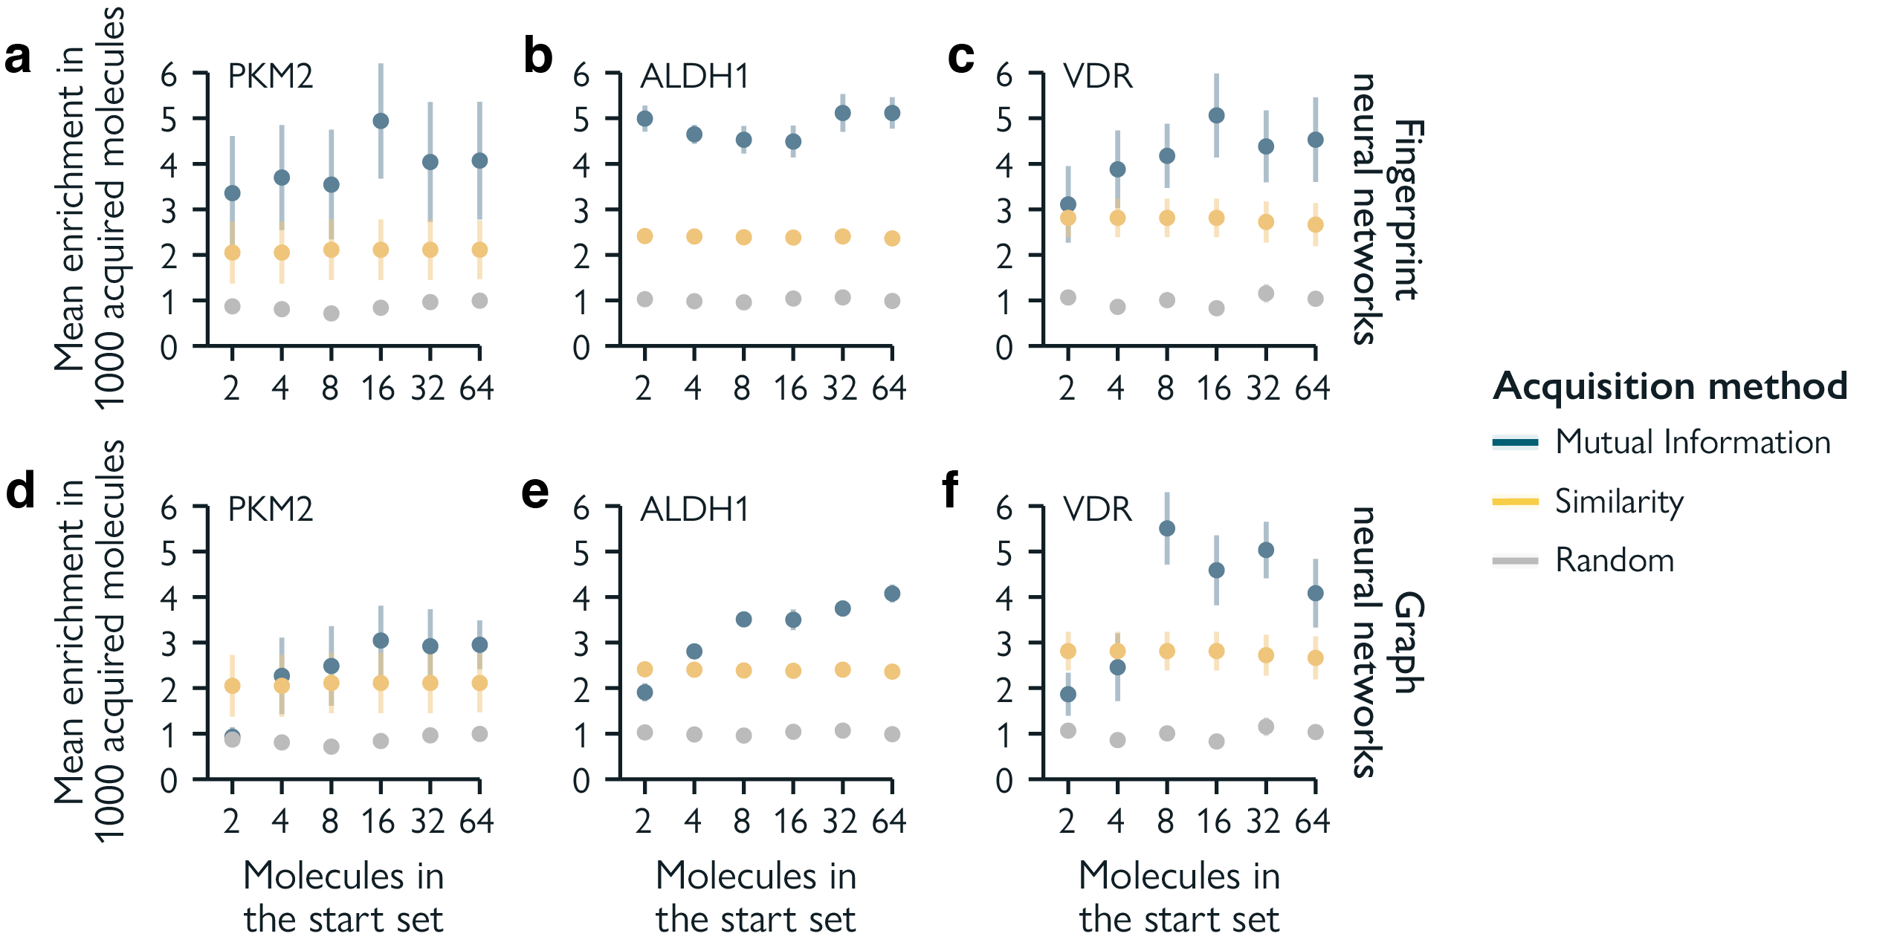
Supplementary Figure 5.8: Effect of acquisition functions on hit discovery for differently sized starting sets. Enrichment factor of all acquired molecules with models trained using ECFPs and molecular graphs, reported across three different datasets. Data is represented as the mean ± SEM of 10 experiments with different random starting molecules. Molecular fingerprints (ECFPs) are reported on the left-hand column, and graph neural networks on the right-hand column. Every row represents one dataset: a, d. PKM2, b, e. ALDH1, c, f. VDR.

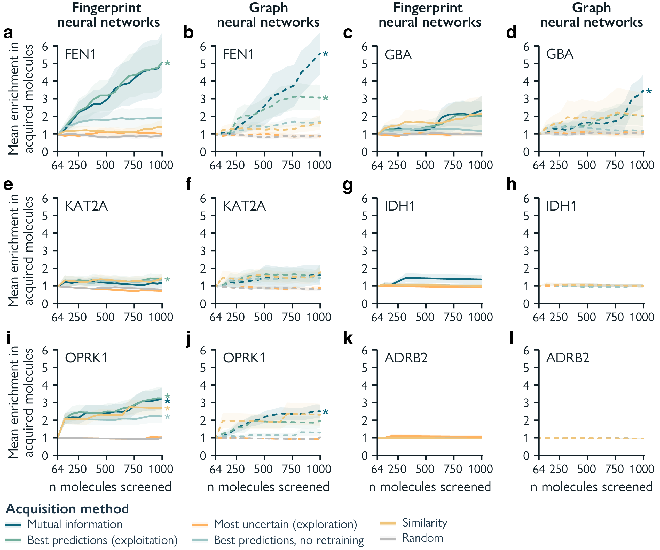
Supplementary Figure 5.9: Effect of acquisition functions on hit discovery on six low-yield datasets. Enrichment factor of all acquired molecules with deep learning models trained using ECFPs and molecular graphs, reported across six different datasets from LIT-PCBA⁴² containing few hit molecules. Data is represented as the mean ± SEM of 10 experiments with different random starting molecules. Molecular fingerprints (ECFPs) are reported on the first and third column (solid line), and graph neural networks on the second and forth column (dashed line). Datasets are shown by order of the number discoverable hits present in the full dataset (n=100,000, see Sup. Table 4): a, b. FLAP endonuclease (FEN1), 100 hits, c, d. Glucocerebrosidase (GBA), 55 hits, e, f. Lysine acetyltransferase 2A (KAT2A), 54 hits, g, h. Isocitrate dehydrogenase (IDH1), 11 hits, i, j. Kappa opioid receptor (OPRK1), 9 hits, k, l. Beta2 adrenergic receptor (ADRB2), 5 hits. Two-sided, paired, Wilcoxon Rank Sum tests are performed without multiple testing correction on the last cycle between random acquisition (grey) and the other acquisition methods. Statistical significance (p < 0.05) is denoted as *.

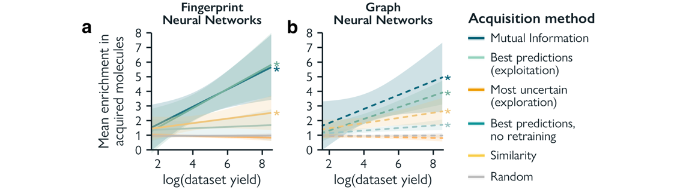
Supplementary Figure 5.10: The relationship between hit discovery and library ‘yield’. Enrichment factor of all acquired molecules at the last active learning cycle with deep learning models trained using ECFPs and molecular graphs, reported across nine different datasets from LIT-PCBA⁴² containing different numbers of discoverable hit molecules (‘yield’). Datasets included from high to low yield are ALDH1 (4,986 hits), VDR (239 hits), PKM2 (223 hits), FEN1 (100 hits), GBA (55 hits), KAT2A (54 hits), IDH1 (11 hits), OPRK1 (9 hits), ADRB2 (5 hits). Data is represented as the mean ± SEM of 10 experiments with different random starting molecules. Results are shown for neural networks trained using ECFPs and molecular graphs. Kendall’s $τ$ is used to test rank-based association, with * noting p < 0.05.

Supplementary Table 5.1: Comparison of selected active learning studies using experimentally obtained data. Studies using docking or simulation-based data are not mentioned. Reker and Schneider¹³ use a bioactivity dataset of 3,780 molecules, which they split into three equal parts (start/library/test). They report prediction error, distribution of bioactivity, and number of molecular scaffolds discovered over cycles. Zhang and Lee²⁸ use six datasets: Melting point (melting temperature), 3,025 molecules; ESOL (solubility), 1,128 molecules; FreeSolv (hydration free energy), 643 molecules; CatS (bioactivity), 595 molecules; Malaria (bioactivity), 13,417 molecules; p450 (bioactivity), 8,817 molecules, of which they use 20% as test sets, 25% as starting set and the remaining as screening library. They report the prediction error over cycles. Bellamy et al.²¹ uses 288 ChEMBL datasets (bioactivity) ranging from 801 to 5,742 molecules and two PubChem bioactivity datasets with 8,817 and 13,417 molecules. They use 100 molecules as the starting set and the remainder as the screening library and report enrichment factor and hits discovered. Li and Rangerajan³⁰ use four datasets: QM7 (enthalpy of atomization), 7,102 molecules; PHYSPROP boiling point (boiling temperature), 5,434 molecules; PHYSPROP melting point (melting temperature), 8,698 molecules; PHYSPROP logP (logP), 13,402 molecules of which they use 400 molecules as starting point and the remainder as screening library. They track prediction error and highest acquired values. Gorantla et al.⁶² use four datasets: TYK2 (binding affinity), 9,997 molecules; USP7 (bioactivity), 4,535 molecules; D2R (bioactivity), 2,502 molecules; and Mpro (bioactivity), 665 molecules. They use 60 molecules as the starting set and the remainder as the screening library and report recall and F1 score. Pyzer-Knapp¹⁸ uses two datasets: MMP12 (bioactivity), 1,880 molecules and Malaria (bioactivity), 18,924 molecules. They start with 20 or 3 molecules respectively and use the remainder as screening library. They report the maximum discovered values, the mean of the top 10%, and hits discovered. Fujiwara et al.¹⁷ use an annotated screening bioactivity library of 240,000 molecules, where they focus on three targets. They start with either 200 or 2,000 molecules, include similarity-based acquisition and report hits discovered. Reker et al.²⁵ use one dataset: CXCR4 (bioactivity) containing 287 molecules, to perform prospective screening on 1,465,960 molecules. They report ligand efficiency and bioactivity. Rakers et al.⁶³ use three datasets: KS5 (bioactivity), 39,706 molecules; GS3 (bioactivity), 47,602 molecules; GLASS (bioactivity), 69,960 molecules. They start with 2 random molecules and use the remainder as screening library. They report MCC and hits discovered.
Study | No. Datasets | Type of data | Train/starting set size | Library size | Approx. library/train ratio | No. acquisition functions
Reker and Schneider¹³ | 1 | Bioactivity | 1,260 | 1,260 | 1 | 3
Zhang and Lee²⁸ | 6 | Bioactivity/physicochemical | 149 – 3,354 | 327 – 7,379 | 2 | 1
Bellamy et al.²¹ | 290 | Bioactivity | 100 | 801 – 5,742 | 8 - 57 | 5
Li and Rangarajan³⁰ | 4 | Physico-chemical | 400 | 5,434 – 13,402 | 14 - 34 | 2
Gorantla et al.⁶² | 4 | Bioactivity/binding affinity | 60 | 655 – 9,997 | 11 – 167 | 4
Pyzer-Knapp¹⁸ | 2 | Bioactivity | 3/20 | 1,880/18,924 | 626/946 | 4
Fujiwara et al.¹⁷ | 3 | Bioactivity | 200/2,000 | 240,000 | 1200/120 | 4
Reker et al.²⁵ (prospective) | 1 | Bioactivity | 287 | 1,465,960 | 5,108 | 2-in-1
Rakers et al.⁶³ | 3 | Bioactivity | 2 | 39,706 – 69,960 | 34,980 | 2
Us | 3 | Bioactivity | 2 - 64 | 100,000 | 50,000 – 1,563 | 5

Supplementary Table 5.2: Statistical differences between hit enrichment with different acquisition methods. Two-sided, paired, Wilcoxon Rank Sum tests are performed without multiple testing correction on the last cycle for the PKM2, ALDH1, and VDR datasets between different acquisition methods. Results are compared per acquisition method for hit enrichment after screening 1000 molecules across different machine/deep learning approaches: fingerprint neural networks (MLP), graph neural networks (GCN), and a random forest control using fingerprints (RF). Statistically significant differences (p < 0.05) are denoted as *.
 |  | Best predictions (exploitation) |  |  | Best predictions, no retraining |  |  | Mutual Information |  |  | Most uncertain (exploration)
 | Model type | MLP | GCN | RF | MLP | GCN | RF | MLP | GCN | RF | MLP | GCN | RF
PKM2 | MLP |  |  |  |  | * |  |  |  |  |  |  | *
 | GCN |  |  |  | * |  |  |  |  | * |  |  | *
 | RF |  |  |  |  |  |  |  | * |  | * | *
ALDH1 | MLP |  | * |  |  |  | * |  | * | * |  | * | *
 | GCN | * |  | * |  |  | * | * |  | * | * |  | *
 | RF |  | * |  | * | * |  | * | * |  | * | *
VDR | MLP |  |  | * |  |  |  |  |  | * |  |  | *
 | GCN |  |  | * |  |  |  |  |  | * |  |  | *
 | RF | * | * |  |  |  |  | * | * |  | * | *

Supplementary Table 5.3: Predictive performance of models with different acquisition functions over active learning cycles. Performance is reported as Receiver Operator Curve Area Under the Curve (ROC AUC) on an independent test set (n=20,000). An acquisition size of 64 was used.
 |  | PKM2 |  |  | ALDH1 |  |  | VDR
 | Acquisition function | Cycle 1 | Cycle 8 | Cycle 15 | Cycle 1 | Cycle 8 | Cycle 15 | Cycle 1 | Cycle 8 | Cycle 15
MLPs+ ECFPs | Mutual Information | 0.426 ± 0.05 | 0.511 ± 0.08 | 0.538 ± 0.07 | 0.493 ± 0.03 | 0.562 ± 0.02 | 0.581 ± 0.01 | 0.655 ± 0.04 | 0.589 ± 0.06 | 0.555 ± 0.07
 | Exploit | 0.426 ± 0.05 | 0.474 ± 0.07 | 0.519 ± 0.10 | 0.493 ± 0.03 | 0.556 ± 0.02 | 0.575 ± 0.02 | 0.655 ± 0.04 | 0.599 ± 0.03 | 0.589 ± 0.03
 | Exploit (no retrain) | 0.426 ± 0.05 | 0.426 ± 0.05 | 0.426 ± 0.05 | 0.493 ± 0.03 | 0.493 ± 0.02 | 0.493 ± 0.03 | 0.655 ± 0.04 | 0.655 ± 0.04 | 0.655 ± 0.04
 | Explore | 0.426 ± 0.05 | 0.498 ± 0.08 | 0.534 ± 0.08 | 0.493 ± 0.03 | 0.552 ± 0.02 | 0.585 ± 0.02 | 0.655 ± 0.04 | 0.660 ± 0.03 | 0.673 ± 0.03
 | Random | 0.426 ± 0.05 | 0.475 ± 0.07 | 0.532 ± 0.07 | 0.493 ± 0.03 | 0.573 ± 0.01 | 0.596 ± 0.02 | 0.655 ± 0.04 | 0.652 ± 0.03 | 0.639 ± 0.04
 | Similarity | 0.426 ± 0.05 | 0.513 ± 0.09 | 0.520 ± 0.09 | 0.493 ± 0.03 | 0.551 ± 0.02 | 0.565 ± 0.01 | 0.655 ± 0.04 | 0.626 ± 0.04 | 0.608 ± 0.05
GNNs | Mutual Information | 0.550 ± 0.05 | 0.580 ± 0.07 | 0.593 ± 0.09 | 0.531 ± 0.03 | 0.580 ± 0.02 | 0.596 ± 0.02 | 0.541 ± 0.06 | 0.542 ± 0.07 | 0.533 ± 0.06
 | Exploit | 0.554 ± 0.04 | 0.594 ± 0.04 | 0.625 ± 0.09 | 0.531 ± 0.03 | 0.588 ± 0.01 | 0.604 ± 0.02 | 0.546 ± 0.06 | 0.526 ± 0.05 | 0.534 ± 0.04
 | Exploit (no retrain) | 0.553 ± 0.04 | 0.553 ± 0.04 | 0.553 ± 0.04 | 0.530 ± 0.03 | 0.530 ± 0.03 | 0.530 ± 0.03 | 0.542 ± 0.06 | 0.542 ± 0.06 | 0.542 ± 0.06
 | Explore | 0.556 ± 0.05 | 0.570 ± 0.06 | 0.584 ± 0.07 | 0.531 ± 0.03 | 0.606 ± 0.02 | 0.633 ± 0.02 | 0.543 ± 0.06 | 0.572 ± 0.05 | 0.575 ± 0.05
 | Random | 0.553 ± 0.04 | 0.564 ± 0.07 | 0.595 ± 0.08 | 0.530 ± 0.03 | 0.597 ± 0.01 | 0.613 ± 0.02 | 0.545 ± 0.06 | 0.576 ± 0.06 | 0.584 ± 0.05
 | Similarity | 0.556 ± 0.04 | 0.617 ± 0.08 | 0.596 ± 0.08 | 0.530 ± 0.03 | 0.586 ± 0.01 | 0.596 ± 0.02 | 0.544 ± 0.06 | 0.547 ± 0.05 | 0.543 ± 0.05
RF + ECFPs | Mutual Information | 0.535 ± 0.05 | 0.552 ± 0.04 | 0.567 ± 0.04 | 0.542 ± 0.02 | 0.573 ± 0.01 | 0.584 ± 0.01 | 0.519 ± 0.06 | 0.546 ± 0.08 | 0.549 ± 0.07
 | Exploit | 0.535 ± 0.05 | 0.548 ± 0.06 | 0.565 ± 0.07 | 0.542 ± 0.02 | 0.586 ± 0.01 | 0.601 ± 0.01 | 0.519 ± 0.06 | 0.528 ± 0.06 | 0.569 ± 0.04
 | Exploit (no retrain) | 0.535 ± 0.05 | 0.535 ± 0.05 | 0.535 ± 0.05 | 0.542 ± 0.02 | 0.542 ± 0.02 | 0.542 ± 0.02 | 0.519 ± 0.06 | 0.519 ± 0.06 | 0.519 ± 0.06
 | Explore | 0.535 ± 0.05 | 0.563 ± 0.08 | 0.571 ± 0.06 | 0.542 ± 0.02 | 0.586 ± 0.01 | 0.603 ± 0.01 | 0.519 ± 0.06 | 0.525 ± 0.05 | 0.523 ± 0.04
 | Random | 0.535 ± 0.05 | 0.548 ± 0.07 | 0.567 ± 0.07 | 0.542 ± 0.02 | 0.591 ± 0.01 | 0.614 ± 0.01 | 0.519 ± 0.06 | 0.582 ± 0.07 | 0.579 ± 0.06
 | Similarity | 0.535 ± 0.05 | 0.540 ± 0.06 | 0.553 ± 0.05 | 0.542 ± 0.02 | 0.581 ± 0.02 | 0.600 ± 0.01 | 0.519 ± 0.06 | 0.521 ± 0.04 | 0.533 ± 0.07

Supplementary Table 5.4: Molecular substructures used for structural analysis and molecular graph featurization. Substructures were identified through different SMILES Arbitrary Target Specification (SMARTS) patterns.

Substructure | SMARTS | Pattern recognition | Graph featurization
Aliphatic chain of at least 8 members | [AR0]~[AR0]~[AR0]~[AR0]~[AR0]~[AR0]~[AR0]~[AR0] | X | X
Bi-cyclicity | [$([*R2]([*R])([*R])([*R]))].[$([*R2]([*R])([*R])([*R]))] | X | X
Ortho-substituted ring | *-!:aa-!:* | X | X
Meta-substituted ring | *-!:aaa-!:* | X | X
Para-substituted ring | *-!:aaaa-!:* | X | X
Macrocycle group | [r;!r3;!r4;!r5;!r6;!r7] | X | X
Spiro-ring centre | [X4;R2;r4,r5,r6](@[r4,r5,r6])(@[r4,r5,r6])(@[r4,r5,r6])@[r4,r5,r6] | X | X
Cis or trans double bond  in a ring | */,\[R]=;@[R]/,\* | X | X
Unfused benzene ring | [cR1]1[cR1][cR1][cR1][cR1][cR1]1 | X | X
Multiple non-fused benzene rings | [cR1]1[cR1][cR1][cR1][cR1][cR1]1.[cR1]1[cR1][cR1][cR1][cR1][cR1]1 | X | X
Fused benzene rings | c12ccccc1cccc2 | X | X
Carbonyl group | [$([CX3]=[OX1]),$([CX3+]-[OX1-])] | X | X
Aldehyde | [CX3H1](=O)[#6] | X | X
Amide | [NX3][CX3](=[OX1])[#6] | X | X
Carbamate | [NX3,NX4+][CX3](=[OX1])[OX2,OX1-] | X | X
Carboxylate ion | [CX3](=O)[O-] | X | X
Carbonic acid or carbonic ester | [CX3](=[OX1])(O)O | X | X
Carboxylic acid | [CX3](=O)[OX1H0-,OX2H1] | X | X
Ester (also hits anhydrides) | [#6][CX3](=O)[OX2H0][#6] | X | X
Ketone | [#6][CX3](=O)[#6] | X | X
Ether | [OD2]([#6])[#6] | X | X
Mono-hydrogenated cation | [+H] | X | X
Amidinium | [NX3][CX3]=[NX3+] | X | X
Cyanamide | [NX3][CX2]#[NX1] | X | X
Primary or secondary amine | [NX3;H2,H1;!$(NC=O)] | X | X
Enamine | [NX3][$(C=C),$(cc)] | X | X
Azole | [$([nr5]:[nr5,or5,sr5]),$([nr5]:[cr5]:[nr5,or5,sr5])] | X | X
Hydrazine | [NX3][NX3] | X | X
Hydrazone | [NX3][NX2]=[*] | X | X
Imine (substituted or un-substituted) | [$([CX3]([#6])[#6]),$([CX3H][#6])]=[$([NX2][#6]),$([NX2H])] | X | X
Iminium | [NX3+]=[CX3] | X | X
Unsubstituted dicarboximide | [CX3](=[OX1])[NX3H][CX3](=[OX1]) | X | X
Substituted dicarboximide | [CX3](=[OX1])[NX3H0]([#6])[CX3](=[OX1]) | X | X
Nitrate group | [$([NX3](=[OX1])(=[OX1])O),$([NX3+]([OX1-])(=[OX1])O)] | X | X
Nitrile | [NX1]#[CX2] | X | X
Nitro group | [$([NX3](=O)=O),$([NX3+](=O)[O-])][!#8] | X | X
Hydroxyl | [OX2H] | X | X
Enol | [OX2H][#6X3]=[#6] | X | X
Phenol | [OX2H][cX3]:[c] | X | X
Carbo-thioester | S([#6])[CX3](=O)[#6] | X | X
Thiol | [SX2] | X | X
Thioamide | [NX3][CX3]=[SX1] | X | X
Sulphide | [#16X2H0] | X | X
Mono-sulphide | [#16X2H0][!#16] | X | X
Two sulphides | [#16X2H0][!#16].[#16X2H0][!#16] | X | X
Sulfone | [$([#16X4](=[OX1])=[OX1]),$([#16X4+2]([OX1-])[OX1-])] | X | X
Sulphonamide | [$([SX4](=[OX1])(=[OX1])([!O])[NX3]),$([SX4+2]([OX1-])([OX1-])([!O])[NX3])] | X | X
Sulfoxide | [$([#16X3]=[OX1]),$([#16X3+][OX1-])] | X | X
Halogen | [F,Cl,Br,I] | X | X
Three halide group | [F,Cl,Br,I].[F,Cl,Br,I].[F,Cl,Br,I] | X | X
Rotatable bond | [!$(*#*)&!D1]-!@[!$(*#*)&!D1] |  | X
Acylic-bonds | *!@* |  | X
Specified chiral carbon | [$([#6X4@](*)(*)(*)*),$([#6X4@H](*)(*)*)] |  | X
Quaternary nitrogen | [$([NX4+]),$([NX4]=*)] |  | X
Non-ring atom | [!R] |  | X
Ring atom | [R] |  | X
Any carbon attached to any halogen | [r;!r3;!r4;!r5;!r6;!r7] |  | X
Triply bonded nitrogen | [$([NX1]#*)] |  | X
Cis/trans double/aromatic  ring bond | */,\[R]=,:;@[R]/,\* |  | X
Hydroxyl in alcohol | [#6][OX2H] |  | X
Thio analogue of carbonyl | [#6X3](=[SX1])([!N])[!N] |  | X
Divalent oxygen | [$([OX2])] |  | X
Isolating carbon | [$([#6+0]);!$(C(F)(F)F);!$(c(:[!c]):[!c])!$([#6]=,#[!#6])] |  | X
Single bond and not in a ring | *-!@* |  | X
S in aromatic 5-ring with lone pair | [sX2r5] |  | X
Aromatic 5-ring O with lone pair | [oX2r5] |  | X
N in 5-membered aromatic ring | [$([nX2r5]:[a-]),$([nX2r5]:[a]:[a-])] |  | X

Supplementary Table 5.5: Summary of low-yield datasets. Subsets of six datasets from LIT-PCBA⁴² were used: FLAP endonuclease (FEN1), Glucocerebrosidase (GBA), Lysine acetyltransferase 2A (KAT2A), Isocitrate dehydrogenase (IDH1), Kappa opioid receptor (OPRK1), and Beta2 adrenergic receptor (ADRB2). Mean and standard deviations of the number of hit molecules in the 10 starting sets are reported. An external test set of 20,000 molecules served to monitor performance over cycles.
Dataset | Screening library size | Test set size | Hits in starting sets
FEN1 | 100,000 (100 hits, 0.10%) | 20,000 (20 hits, 0.10%) | 1.00 ± 0.00
GBA | 100,000 (55 hits, 0.06%) | 20,000 (11 hits, 0.06%) | 1.00 ± 0.00
KAT2A | 100,000 (54 hits, 0.05%) | 20,000 (11 hits, 0.06%) | 1.00 ± 0.00
IDH1 | 100,000 (11 hits, 0.01%) | 20,000 (2 hits, 0.01%) | 1.00 ± 0.00
OPRK1 | 100,000 (9 hits, 0.01%) | 20,000 (2 hits, 0.01%) | 1.00 ± 0.00
ADRB2 | 100,000 (5 hits, 0.01%) | 20,000 (1 hits, 0.01%) | 1.00 ± 0.00

Molecular Descriptors
For the purpose of chemical space visualization (Fig 5.4 and Supp. Fig 5.2), all available molecular descriptors in RDkit⁴ (v. 2022.09.5) were computed for each molecule. The following descriptors were used:
MaxAbsEStateIndex, MaxEStateIndex, MinAbsEStateIndex, MinEStateIndex, qed, SPS, MolWt, HeavyAtomMolWt, ExactMolWt, NumValenceElectrons, NumRadicalElectrons, MaxPartialCharge, MinPartialCharge, MaxAbsPartialCharge, MinAbsPartialCharge, FpDensityMorgan1, FpDensityMorgan2, FpDensityMorgan3, BCUT2D_MWHI, BCUT2D_MWLOW, BCUT2D_CHGHI, BCUT2D_CHGLO, BCUT2D_LOGPHI, BCUT2D_LOGPLOW, BCUT2D_MRHI, BCUT2D_MRLOW, AvgIpc, BalabanJ, BertzCT, Chi0, Chi0n, Chi0v, Chi1, Chi1n, Chi1v, Chi2n, Chi2v, Chi3n, Chi3v, Chi4n, Chi4v, HallKierAlpha, Ipc, Kappa1, Kappa2, Kappa3, LabuteASA, PEOE_VSA1, PEOE_VSA10, PEOE_VSA11, PEOE_VSA12, PEOE_VSA13, PEOE_VSA14, PEOE_VSA2, PEOE_VSA3, PEOE_VSA4, PEOE_VSA5, PEOE_VSA6, PEOE_VSA7, PEOE_VSA8, PEOE_VSA9, SMR_VSA1, SMR_VSA10, SMR_VSA2, SMR_VSA3, SMR_VSA4, SMR_VSA5, SMR_VSA6, SMR_VSA7, SMR_VSA8, SMR_VSA9, SlogP_VSA1, SlogP_VSA10, SlogP_VSA11, SlogP_VSA12, SlogP_VSA2, SlogP_VSA3, SlogP_VSA4, SlogP_VSA5, SlogP_VSA6, SlogP_VSA7, SlogP_VSA8, SlogP_VSA9, TPSA, EState_VSA1, EState_VSA10, EState_VSA11, EState_VSA2, EState_VSA3, EState_VSA4, EState_VSA5, EState_VSA6, EState_VSA7, EState_VSA8, EState_VSA9, VSA_EState1, VSA_EState10, VSA_EState2, VSA_EState3, VSA_EState4, VSA_EState5, VSA_EState6, VSA_EState7, VSA_EState8, VSA_EState9, FractionCSP3, HeavyAtomCount, NHOHCount, NOCount, NumAliphaticCarbocycles, NumAliphaticHeterocycles, NumAliphaticRings, NumAromaticCarbocycles, NumAromaticHeterocycles, NumAromaticRings, NumHAcceptors, NumHDonors, NumHeteroatoms, NumRotatableBonds, NumSaturatedCarbocycles, NumSaturatedHeterocycles, NumSaturatedRings, RingCount, MolLogP, MolMR, fr_Al_COO, fr_Al_OH, fr_Al_OH_noTert, fr_ArN, fr_Ar_COO, fr_Ar_N, fr_Ar_NH, fr_Ar_OH, fr_COO, fr_COO2, fr_C_O, fr_C_O_noCOO, fr_C_S, fr_HOCCN, fr_Imine, fr_NH0, fr_NH1, fr_NH2, fr_N_O, fr_Ndealkylation1, fr_Ndealkylation2, fr_Nhpyrrole, fr_SH, fr_aldehyde, fr_alkyl_carbamate, fr_alkyl_halide, fr_allylic_oxid, fr_amide, fr_amidine, fr_aniline, fr_aryl_methyl, fr_azide, fr_azo, fr_barbitur, fr_benzene, fr_benzodiazepine, fr_bicyclic, fr_diazo, fr_dihydropyridine, fr_epoxide, fr_ester, fr_ether, fr_furan, fr_guanido, fr_halogen, fr_hdrzine, fr_hdrzone, fr_imidazole, fr_imide, fr_isocyan, fr_isothiocyan, fr_ketone, fr_ketone_Topliss, fr_lactam, fr_lactone, fr_methoxy, fr_morpholine, fr_nitrile, fr_nitro, fr_nitro_arom, fr_nitro_arom_nonortho, fr_nitroso, fr_oxazole, fr_oxime, fr_para_hydroxylation, fr_phenol, fr_phenol_noOrthoHbond, fr_phos_acid, fr_phos_ester, fr_piperdine, fr_piperzine, fr_priamide, fr_prisulfonamd, fr_pyridine, fr_quatN, fr_sulfide, fr_sulfonamd, fr_sulfone, fr_term_acetylene, fr_tetrazole, fr_thiazole, fr_thiocyan, fr_thiophene, fr_unbrch_alkane, fr_urea.

5.8 References
1. LeCun, Y., Bengio, Y. & Hinton, G. Deep learning. Nature 521, 436–444 (2015).
2. Qureshi, R. et al. AI in drug discovery and its clinical relevance. Heliyon 9, e17575 (2023).
3. Jiménez-Luna, J., Grisoni, F., Weskamp, N. & Schneider, G. Artificial intelligence in drug discovery: recent advances and future perspectives. Expert Opinion on Drug Discovery 16, 949–959 (2021).
4. Walters, W. P., Stahl, M. T. & Murcko, M. A. Virtual screening—an overview. Drug Discovery Today 3, 160–178 (1998).
5. Stokes, J. M. et al. A Deep Learning Approach to Antibiotic Discovery. Cell 180, 688-702.e13 (2020).
6. Liu, G. et al. Deep learning-guided discovery of an antibiotic targeting Acinetobacter baumannii. Nat Chem Biol (2023) doi:10.1038/s41589-023-01349-8.
7. Neves, B. J. et al. Discovery of New Anti-Schistosomal Hits by Integration of QSAR-Based Virtual Screening and High Content Screening. J. Med. Chem. 59, 7075–7088 (2016).
8. Deng, J. et al. A systematic study of key elements underlying molecular property prediction. Nat Commun 14, 6395 (2023).
9. Van Tilborg, D., Alenicheva, A. & Grisoni, F. Exposing the Limitations of Molecular Machine Learning with Activity Cliffs. J. Chem. Inf. Model. 62, 5938–5951 (2022).
10. Volkov, M. et al. On the Frustration to Predict Binding Affinities from Protein–Ligand Structures with Deep Neural Networks. J. Med. Chem. 65, 7946–7958 (2022).
11. Wallach, I. & Heifets, A. Most Ligand-Based Classification Benchmarks Reward Memorization Rather than Generalization. J. Chem. Inf. Model. 58, 916–932 (2018).
12. Zabolotna, Y. et al. Chemspace Atlas: Multiscale Chemography of Ultralarge Libraries for Drug Discovery. J. Chem. Inf. Model. 62, 4537–4548 (2022).
13. Reker, D. & Schneider, G. Active-learning strategies in computer-assisted drug discovery. Drug Discovery Today 20, 458–465 (2015).
14. Graff, D. E., Shakhnovich, E. I. & Coley, C. W. Accelerating high-throughput virtual screening through molecular pool-based active learning. Chem. Sci. 12, 7866–7881 (2021).
15. Reker, D. Practical considerations for active machine learning in drug discovery. Drug Discovery Today: Technologies 32–33, 73–79 (2019).
16. Murphy, R. F. An active role for machine learning in drug development. Nat Chem Biol 7, 327–330 (2011).
17. Fujiwara, Y. et al. Virtual Screening System for Finding Structurally Diverse Hits by Active Learning. J. Chem. Inf. Model. 48, 930–940 (2008).
18. Pyzer-Knapp, E. O. Bayesian optimization for accelerated drug discovery. IBM J. Res. & Dev. 62, 2:1-2:7 (2018).
19. Gentile, F. et al. Deep Docking: A Deep Learning Platform for Augmentation of Structure Based Drug Discovery. ACS Cent. Sci. 6, 939–949 (2020).
20. Gusev, F., Gutkin, E., Kurnikova, M. G. & Isayev, O. Active Learning Guided Drug Design Lead Optimization Based on Relative Binding Free Energy Modeling. J. Chem. Inf. Model. 63, 583–594 (2023).
21. Bellamy, H., Rehim, A. A., Orhobor, O. I. & King, R. Batched Bayesian Optimization for Drug Design in Noisy Environments. J. Chem. Inf. Model. 62, 3970–3981 (2022).
22. Graff, D. E. et al. Self-Focusing Virtual Screening with Active Design Space Pruning. J. Chem. Inf. Model. 62, 3854–3862 (2022).
23. Desai, B. et al. Rapid Discovery of a Novel Series of Abl Kinase Inhibitors by Application of an Integrated Microfluidic Synthesis and Screening Platform. J. Med. Chem. 56, 3033–3047 (2013).
24. Xue, D. et al. Accelerated search for materials with targeted properties by adaptive design. Nat Commun 7, 11241 (2016).
25. Reker, D., Schneider, P. & Schneider, G. Multi-objective active machine learning rapidly improves structure–activity models and reveals new protein–protein interaction inhibitors. Chem. Sci. 7, 3919–3927 (2016).
26. Yuan, R. et al. Accelerated Discovery of Large Electrostrains in BaTiO ₃ ‐Based Piezoelectrics Using Active Learning. Advanced Materials 30, 1702884 (2018).
27. Mekki-Berrada, F. et al. Two-step machine learning enables optimized nanoparticle synthesis. npj Comput Mater 7, 55 (2021).
28. Zhang, Y. & Lee, A. A. Bayesian semi-supervised learning for uncertainty-calibrated prediction of molecular properties and active learning. Chem. Sci. 10, 8154–8163 (2019).
29. Besnard, J. et al. Automated design of ligands to polypharmacological profiles. Nature 492, 215–220 (2012).
30. Li, B. & Rangarajan, S. A diversity maximizing active learning strategy for graph neural network models of chemical properties. Mol. Syst. Des. Eng. 7, 1697–1706 (2022).
31. Borkowski, O. et al. Large scale active-learning-guided exploration for in vitro protein production optimization. Nat Commun 11, 1872 (2020).
32. Bertin, P. et al. RECOVER identifies synergistic drug combinations in vitro through sequential model optimization. Cell Reports Methods 3, 100599 (2023).
33. Nakano, T., Takeda, S. & Brown, J. B. Active learning effectively identifies a minimal set of maximally informative and asymptotically performant cytotoxic structure–activity patterns in NCI-60 cell lines. RSC Med. Chem. 11, 1075–1087 (2020).
34. Habib Polash, A., Nakano, T., Rakers, C., Takeda, S. & Brown, J. B. Active learning efficiently converges on rational limits of toxicity prediction and identifies patterns for molecule design. Computational Toxicology 15, 100129 (2020).
35. Konze, K. D. et al. Reaction-Based Enumeration, Active Learning, and Free Energy Calculations To Rapidly Explore Synthetically Tractable Chemical Space and Optimize Potency of Cyclin-Dependent Kinase 2 Inhibitors. J. Chem. Inf. Model. 59, 3782–3793 (2019).
36. Khalak, Y., Tresadern, G., Hahn, D. F., De Groot, B. L. & Gapsys, V. Chemical Space Exploration with Active Learning and Alchemical Free Energies. J. Chem. Theory Comput. 18, 6259–6270 (2022).
37. van Tilborg, D. et al. Deep learning for low-data drug discovery: Hurdles and opportunities. Current Opinion in Structural Biology 86, 102818 (2024).
38. Abolhasani, M. & Kumacheva, E. The rise of self-driving labs in chemical and materials sciences. Nat. Synth 2, 483–492 (2023).
39. Seifrid, M. et al. Autonomous Chemical Experiments: Challenges and Perspectives on Establishing a Self-Driving Lab. Acc. Chem. Res. 55, 2454–2466 (2022).
40. Schneider, G., Schneider, P. & Renner, S. Scaffold‐Hopping: How Far Can You Jump? QSAR Comb. Sci. 25, 1162–1171 (2006).
41. Bleicher, K. H., Böhm, H.-J., Müller, K. & Alanine, A. I. Hit and lead generation: beyond high-throughput screening. Nat Rev Drug Discov 2, 369–378 (2003).
42. Tran-Nguyen, V.-K., Jacquemard, C. & Rognan, D. LIT-PCBA: An Unbiased Data Set for Machine Learning and Virtual Screening. J. Chem. Inf. Model. 60, 4263–4273 (2020).
43. Jiang, F. et al. Aldehyde Dehydrogenase 1 Is a Tumor Stem Cell-Associated Marker in Lung Cancer. Molecular Cancer Research 7, 330–338 (2009).
44. Yang, C. et al. Aldehyde dehydrogenase 1 (ALDH1) isoform expression and potential clinical implications in hepatocellular carcinoma. PLoS ONE 12, e0182208 (2017).
45. Palsson-McDermott, E. M. et al. Pyruvate Kinase M2 Is Required for the Expression of the Immune Checkpoint PD-L1 in Immune Cells and Tumors. Front. Immunol. 8, 1300 (2017).
46. Plum, L. A. & DeLuca, H. F. Vitamin D, disease and therapeutic opportunities. Nat Rev Drug Discov 9, 941–955 (2010).
47. Rogers, D. & Hahn, M. Extended-Connectivity Fingerprints. J. Chem. Inf. Model. 50, 742–754 (2010).
48. Kipf, T. N. & Welling, M. Semi-Supervised Classification with Graph Convolutional Networks. Preprint at http://arxiv.org/abs/1609.02907 (2017).
49. Pearce, T., Leibfried, F. & Brintrup, A. Uncertainty in Neural Networks: Approximately Bayesian Ensembling. in Proceedings of the Twenty Third International Conference on Artificial Intelligence and Statistics 234–244 (PMLR, 2020).
50. Truchon, J.-F. & Bayly, C. I. Evaluating Virtual Screening Methods: Good and Bad Metrics for the “Early Recognition” Problem. J. Chem. Inf. Model. 47, 488–508 (2007).
51. Ahneman, D. T., Estrada, J. G., Lin, S., Dreher, S. D. & Doyle, A. G. Predicting reaction performance in C–N cross-coupling using machine learning. Science 360, 186–190 (2018).
52. McInnes, L., Healy, J. & Melville, J. UMAP: Uniform Manifold Approximation and Projection for Dimension Reduction. Preprint at https://doi.org/10.48550/arXiv.1802.03426 (2020).
53. Landrum, G. RDKit: Open-source cheminformatics. (2006).
54. Cereto-Massagué, A. et al. Molecular fingerprint similarity search in virtual screening. Methods 71, 58–63 (2015).
55. Yin, T., Panapitiya, G., Coda, E. D. & Saldanha, E. G. Evaluating uncertainty-based active learning for accelerating the generalization of molecular property prediction. J Cheminform 15, 105 (2023).
56. Paszke, A. et al. PyTorch: An Imperative Style, High-Performance Deep Learning Library. in Advances in Neural Information Processing Systems (eds. Wallach, H. et al.) vol. 32 (Curran Associates, Inc., 2019).
57. Fey, M. & Lenssen, J. E. Fast Graph Representation Learning with PyTorch Geometric. Preprint at http://arxiv.org/abs/1903.02428 (2019).
58. Ioffe, S. & Szegedy, C. Batch Normalization: Accelerating Deep Network Training by Reducing Internal Covariate Shift. Preprint at http://arxiv.org/abs/1502.03167 (2015).
59. Houlsby, N., Huszár, F., Ghahramani, Z. & Lengyel, M. Bayesian Active Learning for Classification and Preference Learning. Preprint at http://arxiv.org/abs/1112.5745 (2011).
60. Kirsch, A., van Amersfoort, J. & Gal, Y. BatchBALD: Efficient and Diverse Batch Acquisition for Deep Bayesian Active Learning. in Advances in Neural Information Processing Systems (eds. Wallach, H. et al.) vol. 32 (Curran Associates, Inc., 2019).
61. Citovsky, G. et al. Batch Active Learning at Scale. in Advances in Neural Information Processing Systems (eds. Ranzato, M., Beygelzimer, A., Dauphin, Y., Liang, P. S. & Vaughan, J. W.) vol. 34 11933–11944 (Curran Associates, Inc., 2021).
62. Gorantla, R., Kubincová, A., Suutari, B., Cossins, B. P. & Mey, A. S. J. S. Benchmarking Active Learning Protocols for Ligand-Binding Affinity Prediction. J. Chem. Inf. Model. 64, 1955–1965 (2024).
63. Rakers, C., Reker, D. & Brown, J. B. Small Random Forest Models for Effective Chemogenomic Active Learning. J. Comput. Aided Chem. 18, 124–142 (2017).

